A seven-week prayer curriculum

Journey Through
The Alliance Vision Prayer

Vision Prayer

O God, with all our hearts, we long for you. Come, transform us to be Christ-centred,
Spirit-empowered, Mission-focused people, multiplying disciples everywhere.
Jasper, AB

Week 1

O God, with all our hearts, we long for you. Come, transform us to be Christ-centred, Spirit-empowered, Mission-focused people, multiplying disciples everywhere.

Vancouver Island, BC

Week 1, Day 1

Bible Readings:
Psalm 42; Psalm 84

Reflection Questions:
- When was the last time you wept in longing for the presence of God?
- In what ways are you pouring out your soul before God these days? Is your soul downcast because it feels like he is absent?
- Is dwelling close to God the greatest longing of your soul? Would you trade 1000 days doing something else for a single chance to be with him?

Prayer Prompts:
- That God would increase the intensity of our longing for him —so much that we would physically feel it.
- That we would do everything we can to be close to his presence.
- That our trust and pursuit of God would be strong even when our souls are downcast, and grief overwhelms us.
- If even the sparrow can find a home near God’s presence, how much more the Yazidis? Pray that Jesus would reveal himself to them.

Listening Prayer:
- Jesus, are there any griefs keeping me from dwelling in your presence?
- How do you want to meet me in my grief today?

Week 1, Day 2

Bible Readings:
Genesis 32:22–32; Colossians 2:1–3; 4:12

Reflection Questions:
- How could you cultivate more longing for God?
- In what ways does your prayer life reflect a struggle on behalf of others?
- How much wrestling with God are you willing to do to receive his blessing and multiply disciples who are firm in obeying his will?

Prayer Prompts:
- That we would long for God’s blessing as much as Jacob did.
- That we would be relentless in seeking God on behalf of the disciples he has called us to make.
- That we would have perseverance in prayer until he blesses our disciples and us.
- That God would give us his longing for the Arab Diaspora to become disciples.

Listening Prayer:
- Jesus, am I longing and wrestling for the right things?
- What do you want me to contend for in prayer until you answer?

Week 1, Day 3

Bible Readings:
Psalm 63; Isaiah 55:1–6

Reflection Questions:
- How thirsty are you for God’s presence? In what ways has his presence been satisfying your soul?
- How are you enjoying God’s love that is better than life?
- What connection might there be between us accepting God’s invitation to come to the waters and summoning the nations as those endowed with splendour?

Prayer Prompts:
- That God would increase our thirst for his presence.
- That we would experience and behold the love, power, and glory of God daily.
- That we would be so endowed with the splendour of Jesus so that the nations would be attracted to God in us.
- That our international workers would effectively reveal the beauty of Jesus to Sasak.

Listening Prayer:
- Jesus, what good and beautiful gift do you have for me as I seek after you today?

Week 1, Day 4

Bible Readings:
Joel 2:12–27; Acts 2:36–41

Reflection Questions:
- Does your hunger/longing for God lead you to mourn over the sin that keeps you from his presence?
- Do you fast, pray and repent of sin?
- How sensitive is your heart to the conviction of the Spirit?
- How does fasting help you express your longing for God’s presence?

Prayer Prompts:
- That we would immediately recognize when we are out of step with the Spirit and quickly repent.
- That we would be quick to radically repent from the heart, not just with religious words.
- That in God’s kindness, he would grant the gift of repentance and faith to the Minnan.

Listening Prayer:
- Jesus, please show me any places where my heart has become insensitive to the conviction of your Spirit.
- Are there any specific ways you call me to show my longing for more of your presence?

Week 1, Day 5

Bible Readings:
Genesis 3:1–10; Daniel 9:1–19; Phil.4:8

Reflection Questions:
- What do you find to be pleasing to the eye and most desirable these days? Is your greatest longing: All Things Jesus?
- Does your shame cause you to hide from God or pursue him through repentance with fasting and tears?
- How does your longing for the glory of God and his reputation among the nations motivate your prayers?

Prayer Prompts:
- That ‘All Things Jesus’ would be the most desirable longing of our lives and that all other longings would pale in comparison.
- That our hearts would be quick to repent to restore intimacy with God rather than to hide in shame.
- That we would humbly plead with God for his forgiveness and that he would use us to reveal his name to the nations.
- That the Fulani in Senegal would see Jesus in our international workers.

Listening Prayer:
- Jesus, in what ways have the eyes of my heart drifted to desire other things more than you?

Week 1, Day 6

Bible Readings:
Isaiah 60:1–5; Ephesians 5:1–20

Reflection Questions:
- Is your greatest longing for the glory of the Lord to rise upon you and to light up our world? What difference will it make for you when he satisfies that longing?
- Is there any hint of immorality or greed in your life? Any darkness?
- What earthly longings do you need to release to create more space to long for God?

Prayer Prompts:
- That God would awaken our hearts with deep longing and ravenous hunger for more of him.
- That our hearts would be filled with joy as the glory of God descends upon us.
- That all dark desires would be banished from our hearts and that we would wholeheartedly long for the beauty of God.
- That each people group we’ve prayed for this week (Yazidi, Arab Diaspora, Sasak, Minnan, and Fulani in Senegal) would see the glory of God revealed in Christ.

Listening Prayer:
- Jesus, are there any self-centred longings that need to die and be replaced with Christ-centred ones?

Week 2

O God, with all our hearts, we long for you. Come, transform us to be Christ-centred,
Spirit-empowered, Mission-focused people, multiplying disciples everywhere.

Montréal, QC

Week 2, Day 1

Bible Readings:
Nehemiah 2:11–18

Reflection Questions:
- How open is your heart to the coming of God and his Kingdom? Is there any part of you that is not ready to invite his presence?
- How might the Lord want you to pray, and where might he want you to step into someone’s story?

Prayer Prompts:
- That the Spirit would show you where he wants you to intercede for your family, your church, and our country.
- Invite God into the brokenness that he’s identified to you to do the redeeming, restoring work only he can do. Invite him to be more present in your thoughts and choices today so you can be more present to others.
- That the North Africans in Spain would recognize their need for Jesus and invite him into their story.

Listening Prayer:
- Jesus, how do you want to come into my story? How do you want to use me to bring your presence into the story of someone else?

Week 2, Day 2

Bible Readings:
2 Samuel 6:12–23; 2 Timothy 4:6–8

Reflection Questions:
- How are you inviting the presence of God to come daily in your life and ministry?
- How are you fighting the good fight in such a way that shows your longing for his appearance?
- Does the joy of God’s presence cause you to celebrate?

Prayer Prompts:
- That we would sacrifice whatever it takes not to hinder the presence of God from dwelling among us.
- That our longing for the Coming King to appear would compel us to sacrificial action on behalf of others.
- That we would pour out our lives to prepare the nations, including the Tajik, for his coming.
- That we would regularly experience his coming among us in such a way that would fill us with great joy.

Listening Prayer:
- Jesus, are there any sacrifices you are calling me to make to prepare the way for your coming?
- What is one step that you are calling me to take today?

Week 2, Day 3

Bible Readings:
Ezekiel 37:1–14; John 20:19–23

Reflection Questions:
- What are the dry bones in your life, or church, that need a fresh visitation of the breath of the Spirit? What might your role be in prophesying to the breath?
- Are there places of fear in your life that need to experience the peace of Jesus?
- Who might Jesus be sending you as the Father sent him?

Prayer Prompts:
- That the presence of Jesus would bring us great peace, even when we face fearful circumstances.
- Pray for the breath of the Spirit to fill those who are discouraged and whose hope is gone.
- That the breath of the Spirit would empower our international workers to bring the forgiveness of Jesus to the Sunda.

Listening Prayer:
- Jesus, how are you calling me to bring your transformational breath of healing to the world?
- What hope do you have for me in my brokenness?

Week 2, Day 4

Bible Readings:
Exodus 33:12–23; Acts 4:23–31

Reflection Questions:
- How are you seeking after the presence of God to empower you for the mission he has given you?
- How does God’s presence in you distinguish you from others?
- Are you desperate for God to show you his glory, to stretch out his hand to heal, and to enable you to speak his Word boldly? Do you ask for this regularly?

Prayer Prompts:
- That the places where we meet for prayer would be shaken with God’s presence.
- That we would all be filled with the Holy Spirit and enabled to speak the Word of God boldly.
- That we would never go anywhere without the presence of God leading the way.
- That the Kurds would see the beautiful presence of Jesus distinguishing his people in such a way that they would desire to follow Jesus as well.

Listening Prayer:
- Jesus, are there ways I have been settling for less than the fullness of your Holy Spirit in my life?
- How can I cultivate a greater longing for your presence?

Week 2, Day 5

Bible Readings:
2 Chronicles 20:1–22; 2 Kings 19:14–19, 35–37

Reflection Questions:
- Are there battles you face alone that you need to invite God to fight for you?
- Is there anything you need to spread out before the Lord for his divine intervention?
- When you feel overwhelmed by challenges—or waiting for God to answer prayer—are you quick to worship or fear?
- How might those challenges be an invitation to trust?

Prayer Prompts:
- That our first instinct when trouble strikes would be to humble ourselves and cry out for God’s intervention.
- That God would use impossible situations to grow our faith and reveal his glory to us and the world.
- That God would come and deliver us from everything that seeks to steal our joy and our effectiveness in extending the Kingdom of God.
- That God would intervene to win the great spiritual battle and bring true freedom to the Western Fulani.

Listening Prayer:
- Jesus, what divine solution do you want me to trust you for in prayer today confidently?

Week 2, Day 6

Bible Readings:
2 Chron. 7:1–16; Exodus 19:9–19; 1 John 3:1–3

Reflection Questions:
- How might God be calling you to prepare yourself for a fresh visitation of his presence?
- Are there any unconsecrated areas of your life that the Spirit is prompting you to surrender to him so that you can be pure as he is pure?
- How willing are you for the extraordinary glory of God to interrupt your plans?
- Do you long for his visitation?

Prayer Prompts:
- That all of us would humble ourselves, pray, seek his face, and turn from our wicked ways so that God would forgive our sins and heal our land.
- That our longing and hope for his coming would compel us to purify ourselves to be like him and prepare.
- That each people group we’ve prayed for this week (North Africans in Spain, Tajik, Sunda, Kurds, Western Fulani) would know the joy of the Father’s great love being lavished upon them as they turn to him in faith.

Listening Prayer:
- Jesus, is anything hindering the full glory of your presence from filling my life and church?
- How can I prepare the way for your presence?
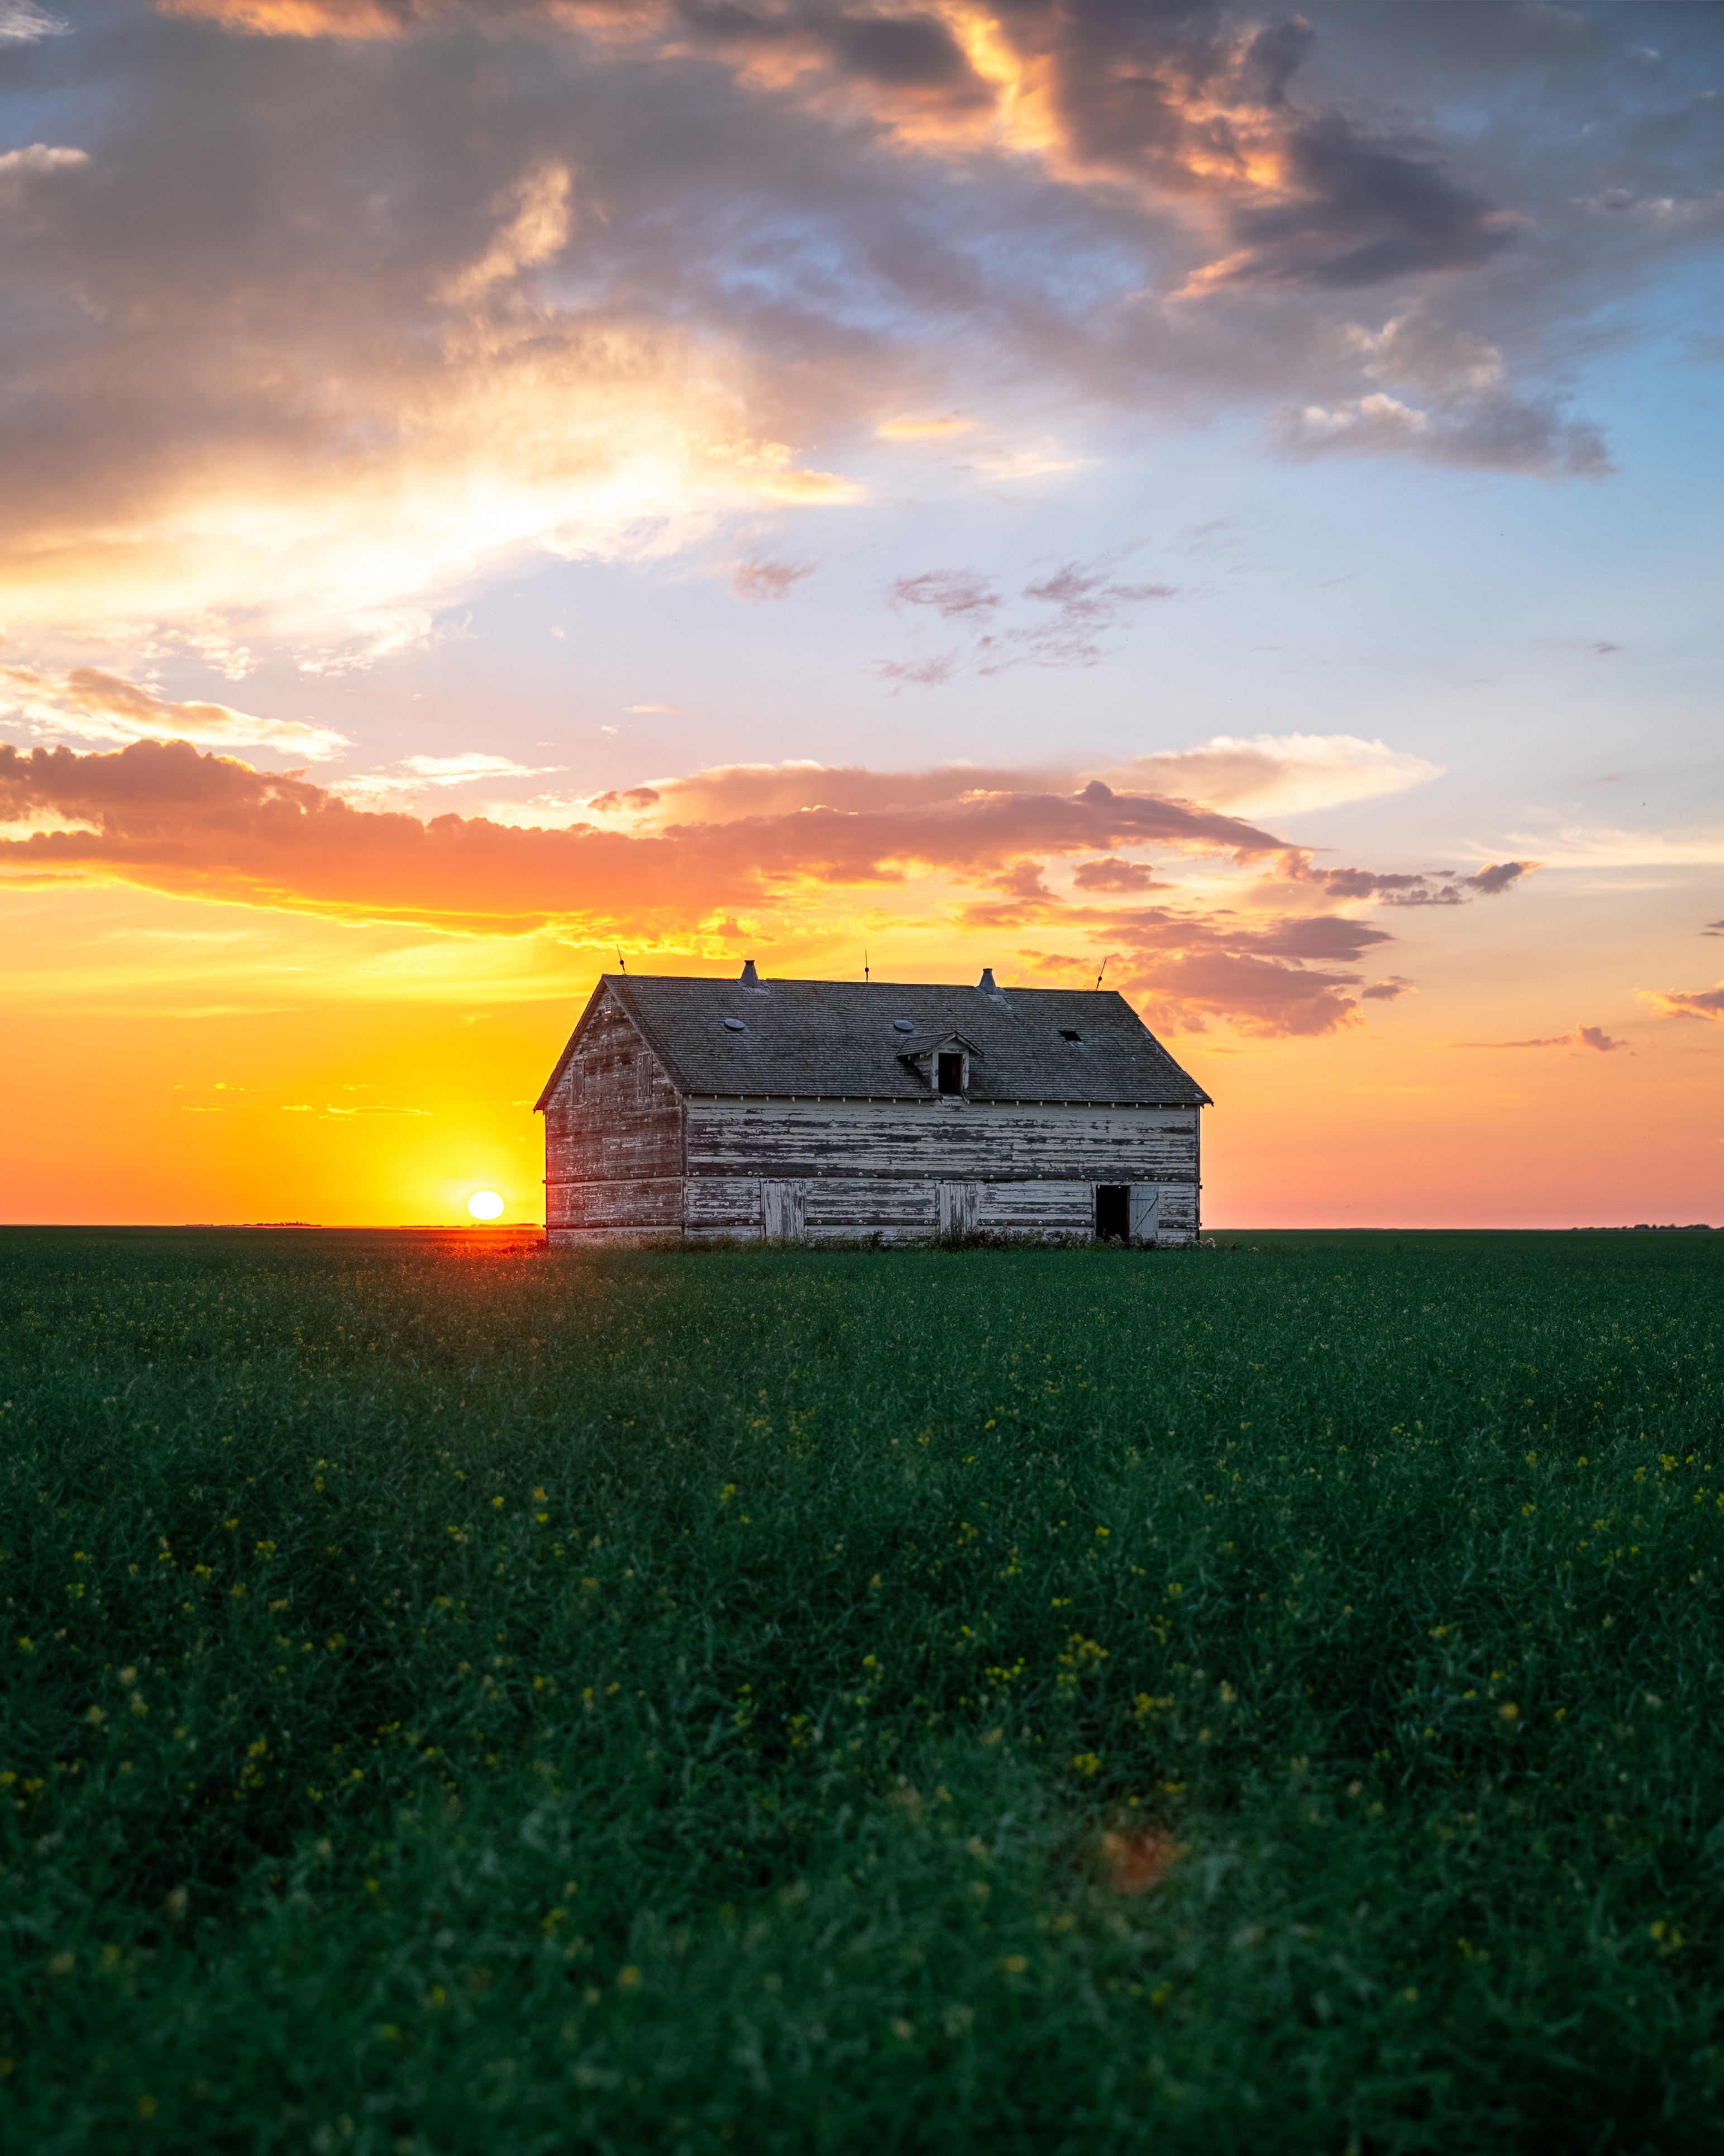

Week 3

O God, with all our hearts, we long for you. Come, transform us to be Christ-centred,
Spirit-empowered, Mission-focused people, multiplying disciples everywhere.
Regina, SK

Week 3, Day 1

Bible Readings:
2 Corinthians 3:3–18; Philippians 1:6; Ephesians 3:20–21

Reflection Questions:
- How is praying “come transform us” similar to the Lord’s Prayer, “your kingdom come, your will be done on earth as it is in heaven”?
- In what ways has your relationship with Jesus changed your life?
- When you pray for yourself and your church, how do you exhibit faith, hope, and imagination?

Prayer Prompts:
- That we would be grateful for all that Jesus has done in our lives and churches.
- That our gratitude for the past transformation we’ve experienced would fuel the desire for ongoing growth into the image of Jesus.
- That we would pursue the metamorphosis that Jesus has in store for us, even that which can only come through loss, hardship, challenge, and sorrow.
- That the lives of God’s people would be a clear demonstration and witness of the love, power, and grace of God to the Urak Lawoi.

Listening Prayer:
- Jesus, what MORE do you have in mind for me, my church, and The Alliance Canada?

Week 3, Day 2

Bible Readings:
Romans 12:1–2; 1 Corinthians 2:6–16

Reflection Questions:
- What patterns of the world are most tempting for you to conform to?
- In what ways does Christ change your perspective on these worldly patterns?
- What might it look like for you to be transformed by renewing your mind so that you become Christ-centred in your thinking?

Prayer Prompts:
- That we would be transformed by the hope of what God has prepared for those who love him, and that he would reveal this hope to us by his Spirit.
- That all our thinking would be aligned with Christ.
- That the patterns of the world would no longer entice us, but instead, we would be captivated by the good, pleasing, and perfect will of God.
- That the Spirit would reveal to South Asian Diaspora the riches of Christ so that they would turn to him.

Listening Prayer:
- Jesus, what is one way that my mind still needs to be renewed and transformed so that it aligns with Yours?

Week 3, Day 3

Bible Readings:
Genesis 28:10–22; 33:1–11; 35:1–3; 49:1–10

Reflection Questions:
- As you reflect on the transformation of Jacob, from one who stole the blessing to one who blessed his sons and the nations, what strikes you?
- What has been your journey of transformation? What chapters do you still long for God to write?
- Are there any broken relationships that you need God to transform? What is your role?
- How do you still need to be transformed so that you can pass on a blessing to your family and the world?

Prayer Prompts:
- That we would all have transformational encounters with God like Jacob.
- That God would transform our perspective so that we can see his face where we would least expect it.
- That God would go before us into our broken relationships to make reconciliation possible.
- That God would take the Tuareg on a journey of transformation into the likeness of Christ.

Listening Prayer:
- Jesus, what is the next step you have for me in my transformation journey?

Week 3, Day 4

Bible Readings:
Genesis 37:12–20; 41:1–16, 33–40; 45:1–11

Reflection Questions:
- As you reflect on the transformation of Joseph, what strikes you?
- Are there points of similarity between your journey of transformation and Joseph’s journey?
- What are the dreams you are still waiting for God to fulfill? Can you see ways that God is transforming you in the process of waiting?

Prayer Prompts:
- That God would redeem the suffering in our lives to bring about the fulfillment of his dreams for us.
- That God’s transforming work in us would have a transforming impact that brings blessing to the world.
- That our hearts would be transformed so thoroughly that we could forgive those who have hurt us deeply.
- That God would transform the suffering of the Uyghur into a great harvest of salvation.

Listening Prayer:
- Jesus, how are you currently at work transforming me to prepare me for the fulfillment of your purposes?
- How can I partner with you in this transformation?

Week 3, Day 5

Bible Readings:
2 Samuel 24:1–25; Psalm 51:1–6; Matthew 3:8

Reflection Questions:
- How might God want to redeem your sins to transform you more into someone after his heart?
- Does the way you deal with your sin demonstrate deep repentance? Does your repentance cost you something, or is it just words?
- What fruit do you observe of the transformation in your life in how you respond after you have sinned? Do you quickly sense the conviction of the Spirit?

Prayer Prompts:
- That our consciences would be sensitive to the conviction of the Spirit when we have sinned.
- That we would be willing to assume the consequences of our sin and not try to hide or defer blame to others.
- That our desire to be in the right relationship with God and one another would compel us to make restitution for the wrongs we have committed.
- That God would soften the hearts of the Chinese Diaspora in Mexico to make them receptive to his invitation to be forgiven.

Listening Prayer:
- Jesus, is there any hidden sin that you want to expose as part of your ongoing transformation in my heart?

Week 3, Day 6

Bible Readings:
John 17:20–26; 1 Cor. 1:10–17; John 13:35

Reflection Questions:
- What would it look like for you to join in the prayer of Jesus for unity among believers? How is this prayer an expression of God’s love?
- How will our ongoing transformation into Christ-centred people lead us into greater humility and enable us to live in unity with others?
- How will our love for one another reveal Jesus to all?

Prayer Prompts:
- That the Body of Christ would be brought to complete unity to let the world know that the Father has sent Jesus because of his love for them.
- That the love of God would transform us to be so Christ-centred that we can love others no matter what.
- That each people group we’ve prayed for this week (Urak Lawoi, South Asian Diaspora, Tuareg, Uyghur, Chinese Diaspora in Mexico) would see the love of God in his people in such a way that they could trust in his love for them.

Listening Prayer:
- Jesus, how are you inviting me to join in your prayer for unity among your people?
- How can I be part of the answer to your prayer

Week 4

O God, with all our hearts, we long for you. Come, transform us to be Christ-centred,
Spirit-empowered, Mission-focused people, multiplying disciples everywhere.

Northern Ontario

Week 4, Day 1

Bible Readings:
Colossians 1:15–23; Revelation 21:1–7

Reflection Questions:
- In what ways am I prone to short-change the person and ministry of Jesus? In my life? In the lives of others?
- Why might I take comfort in a diminished view of who Jesus is and what he has done?
- How might I better understand and commit to Jesus to change or expand my ministry or the ministry of others?

Prayer Prompts:
- That God would show you the practical implications of what a grander understanding of who Jesus is would mean for life and ministry.
- That you would have a constantly growing desire to know and to love Jesus more deeply.
- That God would give you an increased desire to share with others who Jesus is in his fullness.
- That the Kuy would experience the fullness of Jesus and conform to his likeness.

Listening Prayer:
- Jesus, what have I forgotten, overlooked, or not yet realized about who you are that you want me to discover or remember?

Week 4, Day 2

Bible REadings:
Numbers 21:4–9; John 3:9–21

Reflection Questions:
- Are there ways in which you have become impatient with the journey that God is taking you on? How might this be an invitation to centre yourself on Christ?
- Are there ways you have been hiding in the dark for fear of condemnation? How might Jesus be inviting you to come into the light?
- Are you living rooted in your identity of Christ?

Prayer Prompts:
- That our eyes would be centred on Jesus, who has been lifted up through his death and resurrection to save us.
- That we would choose light instead of darkness and gratitude instead of complaining.
- That God would raise workers who would faithfully reveal the beauty of Jesus to the Kazakhs and that they would lift their eyes to him to be saved.

Listening Prayer:
- Jesus, in what ways have my eyes become centred on difficult circumstances instead of centred on you?
- How can I lift my eyes up instead of down?

Week 4, Day 3

Bible Readings:
John 13:1–17; Colossians 3:1–17

Reflection Questions:
- To what extent would you identify with Paul’s statement that “Christ is your life”? How does your life reflect the servant heart of Jesus?
- Are there things at the centre of your life that you need to put to death so that Christ can be the centre?
- How can you clothe yourself with Christ so that the image of the Creator is more clearly reflected in you?

Prayer Prompts:
- That our longing to be All Things Jesus would give us the courage to put everything contrary to death.
- That the compassion, kindness, humility, gentleness, patience, forgiveness, and love of Jesus would be the very centre of how we live as his people.
- That we would follow the example of Jesus in washing the feet of all.
- That the Pashtun would experience the joy of being God’s chosen people, who are holy and dearly loved.

Listening Prayer:
- Jesus, which of your character traits do you want me to focus on putting on today? How can I do that?

Week 4, Day 4

Bible Readings:
Ezekiel 36:24–27; 2 Corinthians 5:11–21

Reflection Questions:
- How has the Spirit been at work in you, transforming your heart of stone into a heart that reflects Christ?
- What is the most significant evidence that you are a new creation with Christ at the centre of your life?
- How does Christ’s love compel you?
- How is Christ empowering you as an ambassador of reconciliation in the world?

Prayer Prompts:
- That the Spirit would move us to embrace God’s very best plan for our lives.
- That our new nature as those in whom Christ dwells would shine brightly for all to see his beauty in us.
- That the love of Jesus would compel us to multiply disciples who experience Jesus as we do.
- That the Tibetan Refugee Diaspora would be reconciled to God and be transformed in Christ.

Listening Prayer:
- Jesus, what are the new things you have birthed in my life through your indwelling presence? Is there any old that is still vying to take centre place?

Week 4, Day 5:

Bible Readings:
Luke 23:26–43; Philippians 2:1–18

Reflection Questions:
- As you read the account of his crucifixion, what is striking to you about Jesus’ attitude?
- How is this same attitude at work in your life?
- Is there any way that Jesus is calling you to consider others better than yourself?
- How might God be inviting you to lean into your identity as a child of God?

Prayer Prompts:
- That our hearts would care for others and offer them forgiveness, even when they treat us poorly.
- That we would look to the interests of others.
- That the Church would shine like stars in the universe because Jesus is at the centre.
- That all the Turks in Germany would bow their knees and confess with their mouths that Jesus Christ is Lord.

Listening Prayer:
- Jesus, how are you inviting me to work out my salvation so that you are at the centre of everything?

Week 4, Day 6:

Bible Readings:
Ephesians 1:15–23; Philippians 3:7–21

Reflection Questions:
- How is the incomparably great power of Christ central to all you do?
- In what ways is Jesus the head over everything in your church? What does this look like in practical terms?
- Is your desire to live a life that is “All Things Jesus” the one thing you strive for? Would you consider everything that is not Christ-centred to be rubbish?
- How is your heavenly citizenship central to the way you live today?

Prayer Prompts:
- That God would give us his Spirit of wisdom and revelation so that we know him better.
- That the power which raised Christ from the dead would transform the way we live as his people.
- That we would know the joy of a Christ-centred life, knowing him in his power and sharing in his sufferings.
- That each people group we’ve prayed for this week (Kuy, Kazakhs, Pashtun, Tibetan Refugee Diaspora, Turks in Germany) would become citizens of heaven.

Listening Prayer:

- Jesus, are there things I need to leave behind so that I can strive after a fully Christ-centred life?

Week 5

O God, with all our hearts, we long for you. Come, transform us to be Christ-centred, Spirit-empowered, Mission-focused people, multiplying disciples everywhere.

Yukon Territory

Week 5, Day 1

Bible Readings:
Luke 3:21–22; 4:1–30

Reflection Questions:
- At his baptism, Jesus was named, blessed, and affirmed by the Father and the Spirit. Do you live with an ongoing sense that you are dearly loved by God?
- How have you experienced the Spirit strengthening you in obedience? Where do you sense his invitation to be conformed to Christ?
- Where do you sense a need for the Spirit to empower your ministry?

Prayer Prompts:
- That you, your loved ones, your church, and your city would experience the love of God; be empowered by the Spirit to walk in holiness and participate in the ministry of Jesus.
- That the North African Arabs would be transformed by the supernatural work of the Spirit among them.

Listening Prayer:
- Jesus, what do you want to reveal to me through your Spirit to hear, see, or do today?

Week 5, Day 2

Bible Readings:
Joel 2:21–32; Acts 2:1–21

Reflection Questions:
- Are there areas in your life where God says: “Be not afraid because my Spirit is with you”?
- Are you expectant for the Spirit to be poured out on you and your church family in transformational ways?
- How is the Spirit’s work among the young and old in your church?

Prayer Prompts:
- That we would have great boldness through the Spirit to not be afraid to declare the wonders of God.
- That all of us would be filled with the Holy Spirit and be anointed with the gifts we need to bring salvation to all the people groups living around us.
- That the presence of the Spirit in our lives would be unexplainable and irresistibly attractive to the world.
- That there would be a glorious harvest of salvation among the Vietnamese Diaspora in Cambodia.

Listening Prayer:
- Jesus, what wonders do you want to release in my life through your Spirit’s work in and through me?

Week 5, Day 3:

Bible Readings:
Exodus 17:8–16; 1 Sam. 12:23; Romans 8:26–27

Reflection Questions:
- How have you experienced the Spirit helping you with your prayers through intercession?
- What battles are you fighting in prayer that you can only win with the help of the Spirit?
- How could the Spirit help you persevere in prayer for others, even when the people you pray for are unresponsive?

Prayer Prompts:
- That God would give you the perseverance to keep praying until he gives you the victories he has called you to fight for.
- That God would raise intercessors to hold up your hands when you are tempted to give up – and that he would help you to do the same for others.
- That God would grant our Alliance family victory in the spiritual battle for the salvation of the Azerbaijani.

Listening Prayer:
- Jesus, is there a battle you are calling me to fight for in prayer with the help of the Holy Spirit and others in my community of faith?

Week 5, Day 4:

Bible Readings:
Exodus 31:1–11; Acts 6:1–15

Reflection Questions:
- Do you believe the Holy Spirit wants to empower ALL you do? How have you seen this in your life?
- Are you surprised that the proposal to find people to wait on tables and care for widows required the candidates to be full of the Spirit? Why or why not?

Prayer Prompts:
- That every person in our churches would be filled with the Holy Spirit and empowered to serve others.
- That we would all receive the Spirit’s wisdom to respond to the challenges and threats we face.
- That God would pour out his Spirit on our artists to empower them to create extraordinary works that will lead us to greater worship and delight in God’s beauty.
- That the opposition to the Gospel among the Huichol would be dispelled by Spirit-empowered believers.

Listening Prayer:
- Jesus, who are the people you are calling me to serve, and what are the things you are calling me to create in the power of the Spirit?

Week 5, Day 5

Bible Readings:
Numbers 11:4–17; Ephesians 4:1–13

Reflection Questions:
- What difficulties are you complaining about these days? What complaints are you receiving from others? Have you asked for the filling of the Spirit to empower you to respond?
- How has the Spirit’s empowerment enabled you to live in unity with others?
- How has the Spirit gifted you for works of service to God’s people?

Prayer Prompts:
- That we would all be completely humble and patient to experience the unity that the Spirit brings.
- That our complaining would be transformed into Spirit-empowered solutions to the challenges we face.
- That God would raise Spirit-empowered believers to partner with us in his Kingdom work.
- That a unified body of believers among the Laotian would be equipped to reach their people.

Listening Prayer:
- Jesus, what do I most need Spirit-empowerment for today? To be humble or patient? To equip others for the work of the Kingdom? To trust and not complain?

Week 5, Day 6:

Bible Readings:
Acts 1:1–14; 4:23–31

Reflection Questions:
- In what ways are you waiting in prayer for the filling of the Spirit to empower you as a witness for Christ?
- Who are you waiting within prayer for this empowerment? Do you pray for this with others?
- What are the threats you face that require supernatural resources from the Spirit to respond to?
- Do you need to ask God to stretch out his hand to heal and perform miraculous signs and wonders?

Prayer Prompts:
- That our longing to be effective in Spirit-empowered mission would compel us to seek this with others.
- That God would enable us to speak his Word with great boldness and love and that it would be accompanied by the supernatural power of the Spirit to heal and transform lives.
- That among each people group we’ve prayed for this week (North African Arabs, Vietnamese Diaspora in Cambodia, Azerbaijani, Huichol, Laotian), God would stretch out his hand to reveal the glory of Christ to them.

Listening Prayer:
- Jesus, what keeps me from greater fullness of your Spirit’s empowerment today?

Week 6

O God, with all our hearts, we long for you. Come, transform us to be Christ-centred,
Spirit-empowered, Mission-focused people, multiplying disciples everywhere.

Newfoundland and Labrador

Week 6, Day 1:

Bible Readings:
Genesis 12:1–3; Psalm 67; Romans 15:14–22

Reflection Questions:
- How has God blessed you and made his face to shine on you?
- How has God called you to be a blessing to the world, that all the people would praise him?
- How are you personally partnering with the ambition God has given The Alliance to preach the Gospel where Christ is not known?

Prayer Prompts:
- That God would bless our Alliance family and use us as a blessing to the world.
- That we would always long to do everything we can to share the Gospel, and that we would have the perseverance to do this when it’s hard.
- That Christ would accomplish great things through our international workers and Kazakh believers in leading the Japanese to obey God by what they say and do.

Listening Prayer:
- Jesus, how do you want to multiply the blessings you have given to me so that the greatest number of people would love you in the greatest possible way?

Week 6, Day 2:

Bible Readings:
Genesis 18:16–33; Ezekiel 22:30; Acts 16:6–10

Reflection Questions:
- Are you willing to stand like Abraham in a place of intercession on behalf of those in danger of judgment?
- How have you seen the Spirit opening and closing doors to show you the people you are called to reach?
- Are you prepared to get ready at once and respond to God’s call to join him?
- How is God stirring your heart for the lost?

Prayer Prompts:
- That God would show us the people he calls us to go to.
- That the Spirit would close doors as needed to focus our missional efforts on the places he has prepared.
- That God would help us stand in the gap in compassionate intercession for the lost.
- That God would prophetically raise workers to go to the Kazakh Uyghurs and share the Gospel with them.

Listening Prayer:
- Jesus, how do you want to grow my love for people and focus on reaching them with the Gospel?
- In what ways has my focus been diverted from the mission you have called me to join you in?

Week 6, Day 3:

Bible Readings:
Jonah 4:1–11; Luke 15:1–10

Reflection Questions:
- How would you compare your level of concern for your comfort and well-being with your level of respect for those who are far from Christ?
- Does your focus on mission compel you to search for the lost and intentionally pursue their rescue carefully?
- Are you overjoyed when a new believer comes to faith in Christ? How is your life focused on helping this happen as often as possible?

Prayer Prompts:
- That our hearts would be tender and compassionate towards those far from Christ.
- That the fruit of our mission would be much rejoicing in heaven over the many sinners who repent.
- That as The Alliance, we would not give up in our pursuit of the Yemeni Refugee Diaspora, but that we would search carefully and pursue every possible option until they embrace Christ.

Listening Prayer:
- Jesus, how can I join you in your careful search of those you are pursuing?

Week 6, Day 4:

Bible Readings:
Isaiah 61:1–4; Luke 4:14–30; 1 John 3:8

Reflection Questions:
- How are you partnering with Jesus in his Spirit-empowered mission to share Good News?
- Who are the oppressed that God has put on your heart to serve in the power of the Spirit?
- Are you only focused on reaching your hometown, or are you partnering to reach those from other places as well?

Prayer Prompts:
- That we would have eyes to see the broken hearts of those around us and compassion to reach out with the healing presence of Jesus.
- That God would give us his passion to reach those both far and near with the Gospel of Jesus and that our focus would be firmly set on fulfilling his mission.
- That God would help us to partner with him in destroying the works of the devil.
- That God would transform the Rohingya and that they would know him.

Listening Prayer:
- Jesus, how can I join you in your mission to rebuild ancient ruins and restore places long devastated?

Week 6, Day 5:

Bible Readings:
Jeremiah 1:4–10; Acts 13:1–12

Reflection Questions:
- Do you believe that God set you apart from before you were born to join him in his mission? How has he called you to participate?
- Are you in a group that regularly gathers to worship the Lord and fast? How is God calling your community of faith to join him?
- How has the filling of the Spirit in your life given you the courage to confront evil and set the captives free?

Prayer Prompts:
- That God would raise more workers.
- That all of us would hear God’s call for our lives and join him wherever he has placed us.
- That the workers among the Spaniards would, with the authority of Christ, bring healing and transformation to Spaniards.

Listening Prayer:
- Jesus, how can I partner with you today in bringing light to the darkness?
- Do you have any special assignments for me today?

Week 6, Day 6:

Bible Reading:
Acts 5:17–42

Reflection Questions:
- If an angel asked you to tell someone “the full message of this new life.” how would you describe it? How has your new life in Christ transformed you?
- Is your experience of the fullness of life in Christ so rich that you would rejoice to be counted worthy of suffering disgrace for his name? What might it look like for you to experience the joy of Jesus more fully?
- The apostles considered their witness about Christ an act of obedience. What act of obedience is God asking from you?

Prayer Prompts:
- That our mission-focused vision would be fueled by our fulsome experience of our new life in Christ.
- That the greatest joy of our lives would be introducing people to Jesus, even when it comes at a cost to us.
- That all attempts to stop the Gospel from spreading among the people groups we’ve prayed for this week (Japanese, Kazakh Uyghurs, Yemeni Refugee Diaspora, Rohingya, Spaniards) would be thwarted because God is fighting for their salvation.

Listening Prayer:
- Jesus, what is one aspect of the new life you have given me that I could share with someone this week?

Week 7

O God, with all our hearts, we long for you.
Come, transform us to be Christ-centred,
Spirit-empowered, Mission-focused people, multiplying disciples everywhere.

Winnipeg, MB
Week 7, Day 1:

Bible Readings:
Luke 10:1–2; Matthew 10:24–25; 28:18–20; 2 Cor 5:14–15.

Reflection Questions
- As a disciple of Jesus, how deeply do you value being and making disciples?
- What concrete steps have you recently taken as Christ's disciple to be like Jesus?
- Name one person you are in a disciple-making relationship with.

Prayer prompts
- That the Holy Spirit will fill us with the passion of being disciples and making disciples.
- That God would pour out his divine anointing on all those around the world who are involved in disciple-making, especially for those in limited-access nations.
- That the Southern Thai would become disciples who make disciples conformed to the likeness of Jesus.
- Let us join the early Church in praying, “Maranatha, Come Lord Jesus!”

Listening Prayer:
- Jesus, what are you saying to the Church and me today in the specific area of disciple-making?
- How can I join you in this mission today?

Week 7, Day 2:

Bible Readings:
Matthew 28:16–20; John 20:19–23

Reflection Questions:
- How does the authority given to Christ give you courage for the work of making disciples?
- How would you teach a new disciple to obey what Jesus commanded?
- Who is Jesus sending you to? Have you received the filling of the Spirit to be empowered for the task? Ask for this gift today!

Prayer Prompts:
- That all our efforts to multiply disciples locally and globally would be anointed with the authority and presence of Christ.
- That our disciple-making would be transformational.
- That there would be such a multiplicative disciple-making movement among the Gulf Arabs and they would be able to join us in reaching other least-reached people groups as well.

Listening Prayer:
- Jesus, how can I bring your presence and authority into everything I do to multiply disciples?

Week 7, Day 3:

Bible Readings:
Acts 20:17–24; 1 Corinthians 9:19–27

Reflection Questions:
- What most strikes you about Paul’s efforts to multiply disciples everywhere?
- Paul was “all in” when it came to disciple-making. What would “all in” look like for you?
- How could you leave your comfort zone to make the Gospel relevant to those God has called you to reach?

Prayer Prompts:

- That we would pursue all possible means to multiply disciples and have the courage to do all we can to provide access to Jesus for all people.
- That we would be compelled to complete the missional tasks that Jesus has given us and that we would do so with great humility and heartfelt tears.
- That our international workers among the Wolof would have Spirit-empowered wisdom to contextualize the Gospel and lead them to become disciples of Jesus.

Listening Prayer:
- Jesus, what is one way I could identify with those you call me so that I might make an impact?

Week 7, Day 4:

Bible Readings:
Genesis 41:14–16/25–40; 1 Peter 2:9–12

Reflection Questions:
- Why did Pharaoh extend such favour to Joseph? How did the quality of his life among the pagans lead to the salvation of the nations?
- How might you gain favour with those you connect with? How could this help you to multiply disciples?
- What distinguishes you in the eyes of the unbelievers around you?
- How does your life declare the praises of God in a way that is attractive to others?

Prayer Prompts:
- That God would raise wise and discerning leaders to faithfully represent Christ in positions of influence in our country and world.
- That the strength, beauty, and wisdom of our lives would have a transformational impact on the lives of others, leading many to become disciples of Jesus.
- That Amdo Tibetans would say of our international workers what was said of Joseph: ‘There is no one so discerning and wise as you.”

Listening Prayer:
- Jesus, what is one way that I can best reflect your wisdom and beauty to those I connect with today?

Week 7, Day 5:

Bible Readings:
Zechariah 8:20–23; Acts 17:16–34

Reflection Questions:
- How did Paul respond to the distressing reality he encountered in Athens? How could we respond in similar ways to anything that opposes Christ?
- What are ways to make the Gospel relevant and attractive today without losing the truth?
- One day, people from all nations will say: “Let us go with you because we have heard that God is with you.” Do our lives reflect the beauty of Emmanuel in such a way that others would want to join us in being his disciples?

Prayer Prompts:
- That Christ in us would shine brightly for all to see—and that many would long to join us as his disciples.
- That we would have the wisdom to reveal the unchanging truth and beauty of Jesus in ways that our changing world can understand and appreciate.
- That the Punjabi Arain would undeniably see that God is with his people and join us in being his disciples.

Listening Prayer:
- Jesus, is there anything in my life that is hindering me from reflecting your presence to those around me?

Week 7, Day 6:

Bible Readings:
Daniel 2:24–30; 3:13–30; 4:34–37

Reflection Questions:
- How did Daniel and his friends have a transformational impact on the pagan nation of Babylon? How did their faithful witness to Nebuchadnezzar have a multiplicative effect on all the countries in the empire?
- In an increasingly post-Christendom society, how might we have this kind of transformative impact for Christ and multiply disciples everywhere?

Prayer Prompts:
- That we would have the courage to follow Christ even when this brings hostility from others boldly, and that we would have the wisdom to do so in ways that humbly and beautifully reflect the character of Jesus.
- That the power of Christ in us would deliver us from evil and convince many to join us in being his disciples.
- That the eternal dominion of Jesus would be revealed to each people group we’ve prayed for this week (Southern Thai, Gulf Arabs, Wolof, Amdo Tibetans, Punjabi Arain), and that they would praise and exalt and glorify his name.

Listening Prayer:
- Jesus, how can I multiply disciples everywhere?
- What is the unique role you are calling me to play?
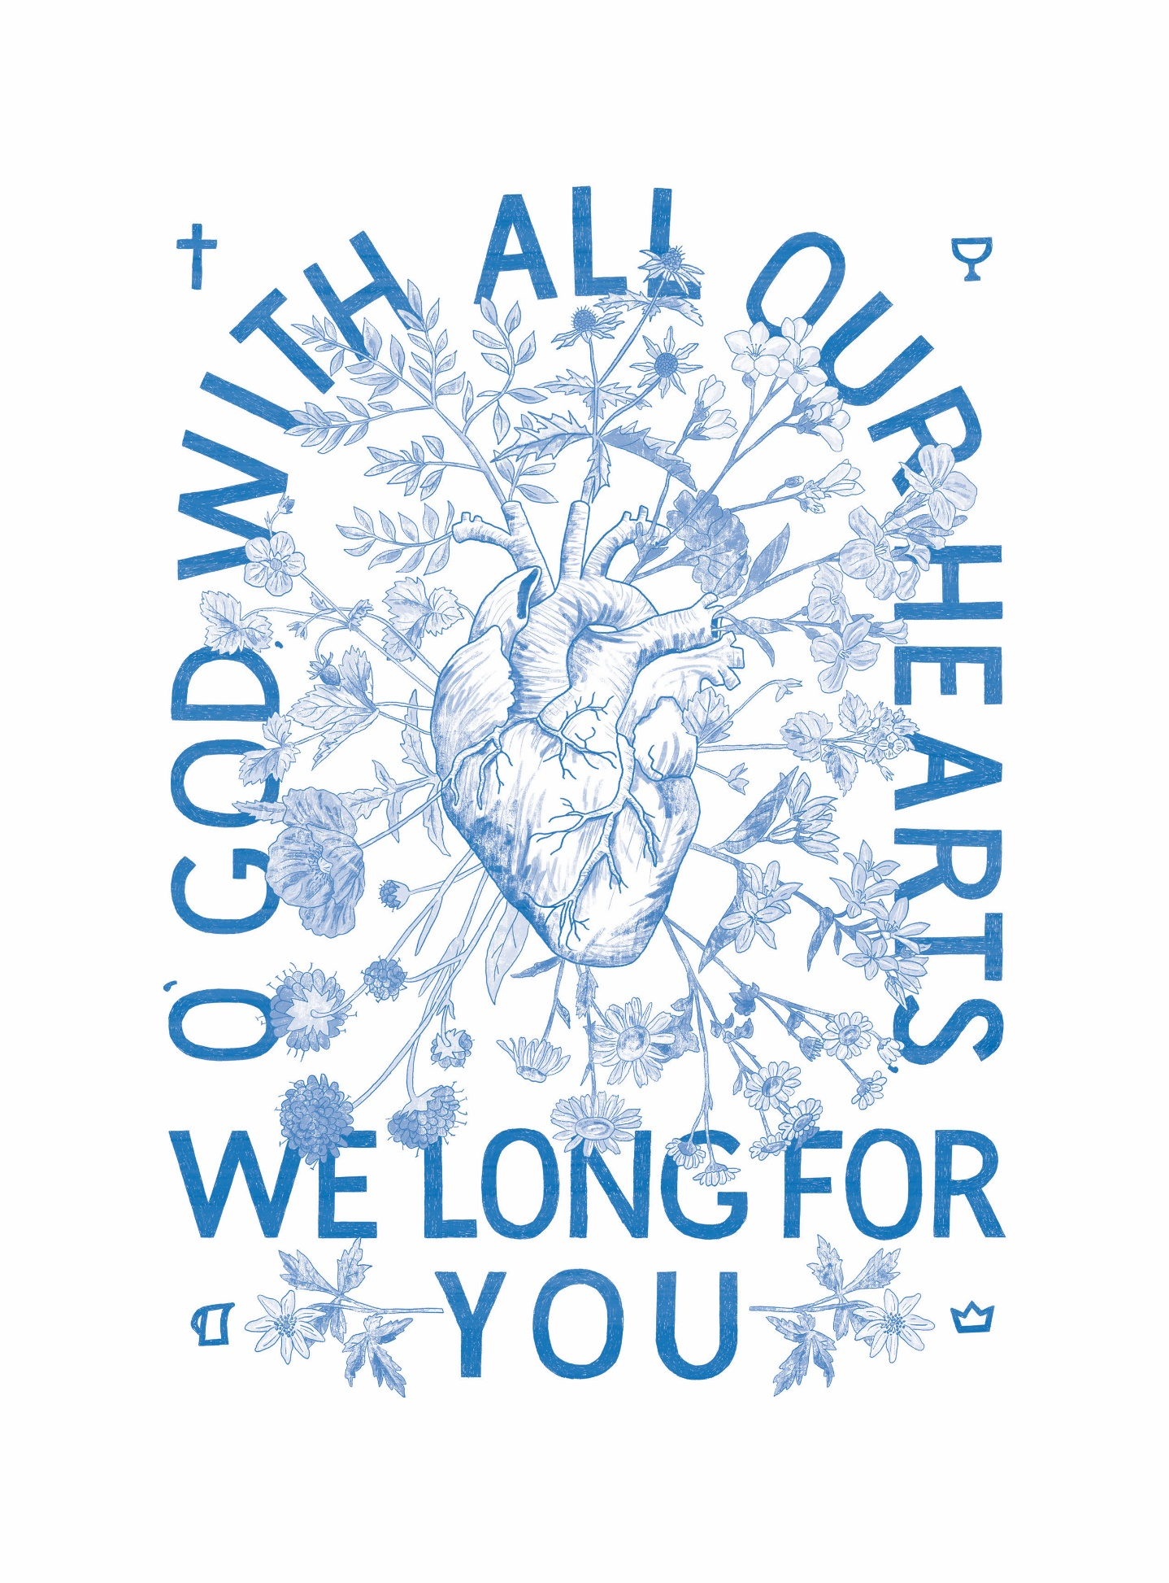
The Alliance Vision Prayer
The hand-lettering is the first half of the prayer.
and the illustration represents the second
half of the prayer: that our hearts would be
transformed and multiply life.

A Prayer Guide for Blessing the Nations

“In Blessing I will Bless You” (Genesis 12:2–3; 22:17)
“I will make you a great nation; I will bless you and make your name great; and you shall be a blessing. I will bless those who bless you, and I will curse him who curses you; and in you all the families of the earth shall be blessed.” Genesis 12:2–3
The blessings of Abraham extend to many generations and even to the ‘families of the earth’—the nations. We can proclaim the blessing of the Lord over our families, cities, and countries. We can make known his goodness and invoke his blessing over every sphere he has put in our lives. By blessing others, we give them honour and declare life for them—the life that comes through the relationship with the Giver of Life.
Every ethnos has a redemptive gift. Man, made in the image of God, demonstrates to greater or lesser extent aspects of the Creator. We can call out these dimensions of their nature and practice that we recognize in them and ask God to call it forth to focus on their Creator. In that, we bless the work done by the Creator in shaping each ethnicity so wonderfully.
Jesus became a curse by hanging on the cross and opened the way of blessing to those under the curse. “Christ has redeemed us from the curse of the law, having become a curse for us (for it is written, ‘Cursed is everyone who hangs on a tree’), that the blessing of Abraham might come to the Gentiles in Christ Jesus, that we might receive the promise of the Spirit through faith.” (Galatians 3:13, 14, NKJV)
The redeemed do not curse; we are people of blessing. This prayer guide comes with the hope that together, we can bless the nations to know the blessing of the Lord that ‘makes rich and adds no sorrow with it’ (Proverbs 10:22). The blessing of the Lord is the nearness of his presence. Come Lord Jesus to these beloved peoples. Bless them with the adoption as children of God, for they are wonderfully made by you.
Please join us in speaking life over these people by proclaiming the prayer of blessing out loud each day for the people group we are praying for. “The tongue has the power of life and death” (Proverbs 18:21)
Join us in singing a blessing over the nations:
https://www.youtube.com/watch?v=GjWI4CLmBbE

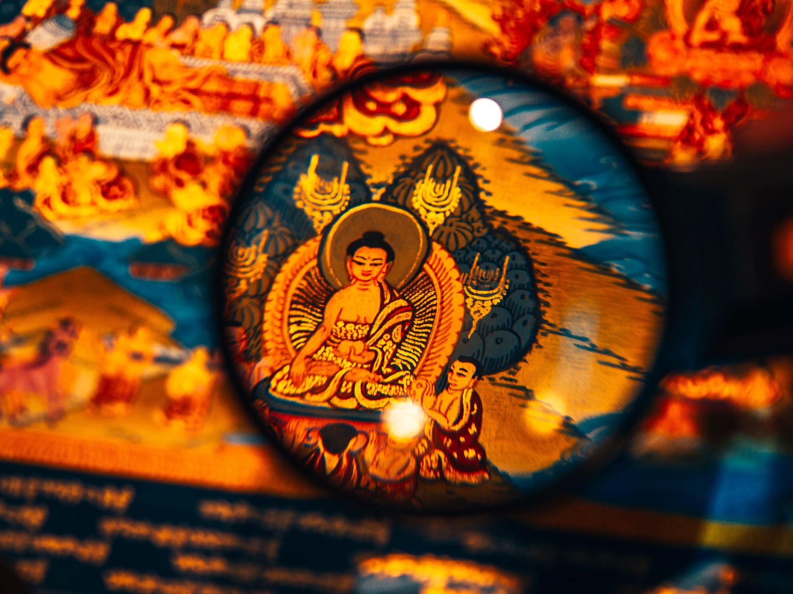
Amdo Tibetans
About 1.2 million Amdo Tibetan make up the six million Tibetans living in China. Most live and work as farmers and herders. About 10,000 Tibetans are living in Canada.
Their religion and culture are deeply integrated, and many believe: ‘I am Tibetan; therefore, I am a Tibetan Buddhist.’ Most Tibetans have a dedicated space in their homes with ritual objects they use daily.
Although few, Tibetan believers are growing in their faith, becoming bold, and caring for fellow believers in the countryside and neighbouring countries. Many Christian resources have been produced for Tibetan Buddhists. However, the long-hoped-for revival lags behind the effort. Enter the intercessors. Will you join us in praying for Tibetans?

Pray with us:
Father, you have formed us in your image so that creation might worship and adore you, our Creator. Would you bless Tibetans with the joy that comes from fellowship with the Eternal in worship? As they worship, will you let the emptiness of idolatry overcome them so that they will seek the God who loves them, with all their heart, soul, and mind?
Connect Tibetan Buddhists with Tibetan Christians who are serving you. Let the exuberant worship of Tibetans become unending praise to their Creator through salvation in Jesus. May their constant and passionate worship be turned toward you, Jesus. Amen.

Arab Diaspora
Canada has a substantial population of Arab diaspora. Approximately 1 million Arabs living in Canada are from Egypt, Syria, Jordan, Palestine, Lebanon, and Iraq. Many people from the Arab diaspora have left their passport countries for better career opportunities and political stability.
Most Arabs are Muslim and deeply value hospitality, close family ties, and Islamic ideals. They are often resistant and can even be hostile towards gospel witnesses. Believers who convert from a Muslim background are often disowned by family and ostracized by their community. In many cases, even their lives are threatened. The exact number of Muslim background believers is not known but thought to be minimal.

Pray with us:
Father, we bless Arab Muslims with a pouring out of your Spirit through dreams and visions.
May they encounter faithful Christian witnesses. We bless them to understand the kind of peace. you offer. Through entering a relationship with you, we pray that they would experience the peace and freedom that comes from knowing that you have already paid the debt for all sin.
Flood them with your perfect love that washes away all fear. We bless the believers among them with courage, boldness, and perseverance to bear witness to the Gospel—even through suffering and persecution. We bless their witness to bear fruit, resulting in an increased harvest of souls. Amen.

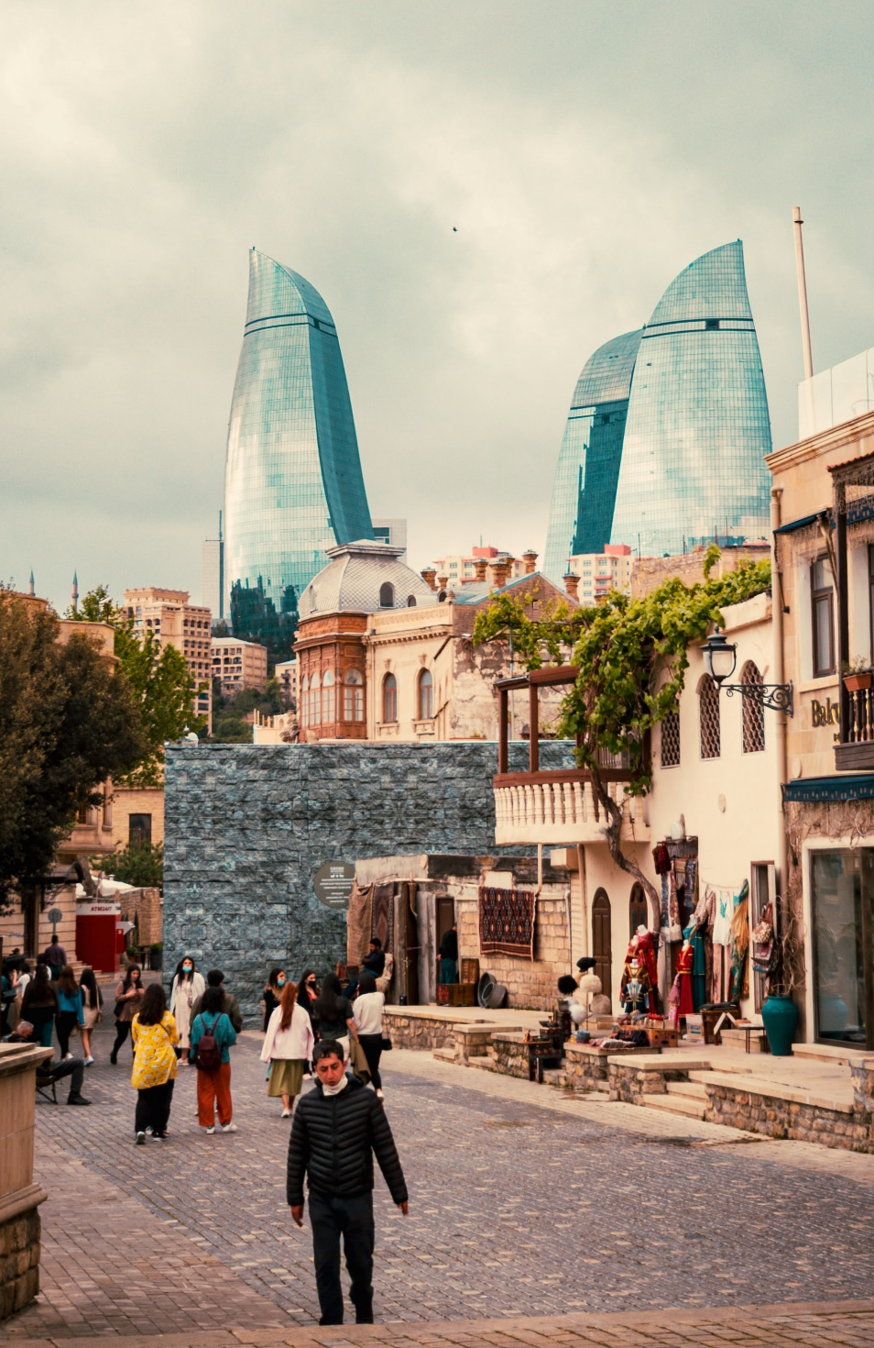
Azerbaijani
Zoroastrianism, most widely known for its element of fire worship, was commonly practiced in ancient times and originated in Azerbaijan. Evidence of this old religion is still prolific today. After the disciple Bartholomew preached in Azerbaijan, Christianity grew to be the official religion by the 4th century. Islam became prominent in the 7th century, and as a result, Azerbaijani culture today shows little evidence of its Christian heritage. Today, 90% of Azerbaijani follow Islam.
Azerbaijani value loyalty and hospitality. Tea and bread are considered daily essentials. Azerbaijan is the wealthiest post-Soviet country due to oil and natural gas. However, corruption has slowed development and created economic hardship.
There are 8.8 million Azerbaijani in Azerbaijan and over 20 million in Iran, of which less than 0.25% are believers. About 7,000 Azerbaijanis live in Canada, predominantly in the Toronto area.

Pray with us:
Father, rebuild ancient ruins that have been devastated; restore a temple of praise. Restore the Azerbaijani to their gospel roots! Open their eyes to see you and increase their longing to worship you. Bless believers with an increased knowledge of the Scriptures. Anoint them with your Spirit, enabling them to be faithful and bold in witness, withstanding persecution. We call for more workers among the Azerbaijani and ask that a Bible school be established. Bless them with eternal satisfaction in you, Jesus, and we thank you that you are the bread of life. Whoever comes to you will never go hungry, and whoever believes in you will never be thirsty (John 6:35). Amen.

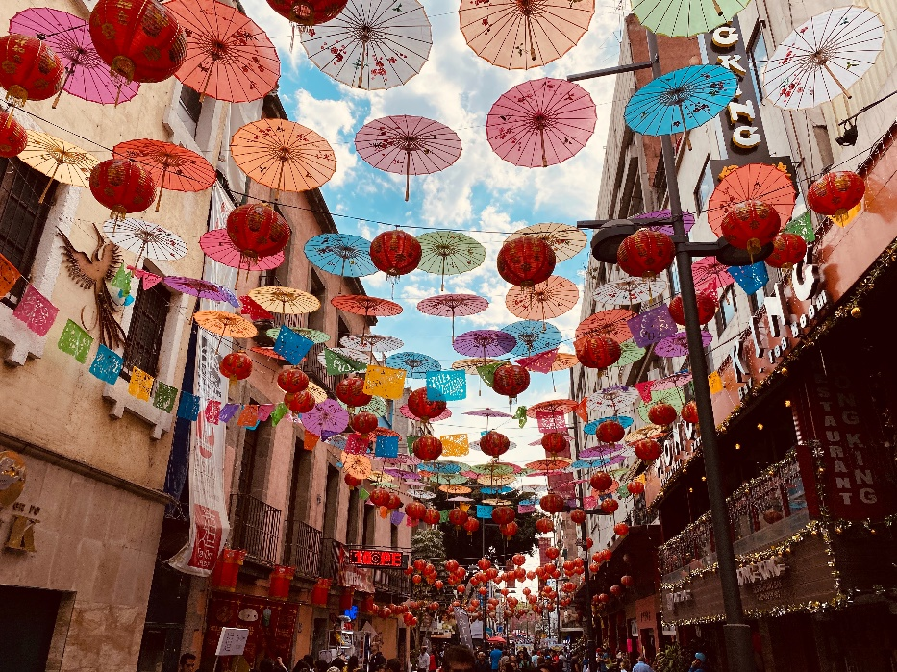
Chinese Diaspora in Mexico
The Han Chinese are the world's largest ethnic group, and although the majority live in mainland China, significant populations are reported in 62 countries worldwide. Less than 2% of the Chinese diaspora in Mexico are Christian.
Thankfully there is some receptivity to the Gospel. The Joshua Project reports that there are about 1,268,000 Chinese that call Canada home, and about 8% of them are evangelical Christians. Most Chinese are either atheist or Buddhist.

Pray with us:
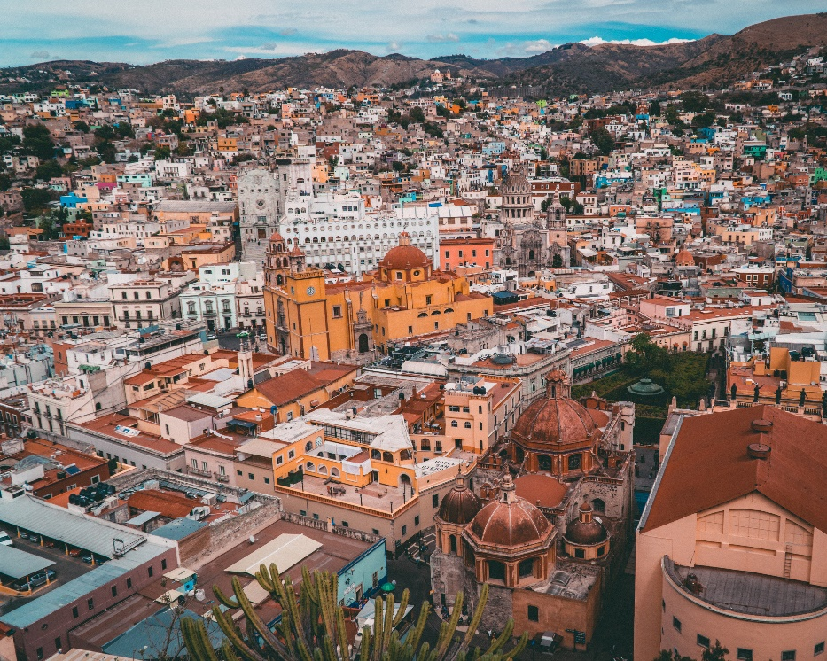
Jesus, we thank you that when you were on earth, you journeyed through all the towns and villages, teaching, proclaiming the good news, and healing people. Would you send your Spirit to every village, town, and city the Chinese call home and draw them onto the narrow path towards you.

We bless the Chinese to come to know you as saviour. We pray for the blessing of surrender for those on the journey towards you. Lord, bless them by sending workers to proclaim the good news to the Chinese wherever they live. Amen.

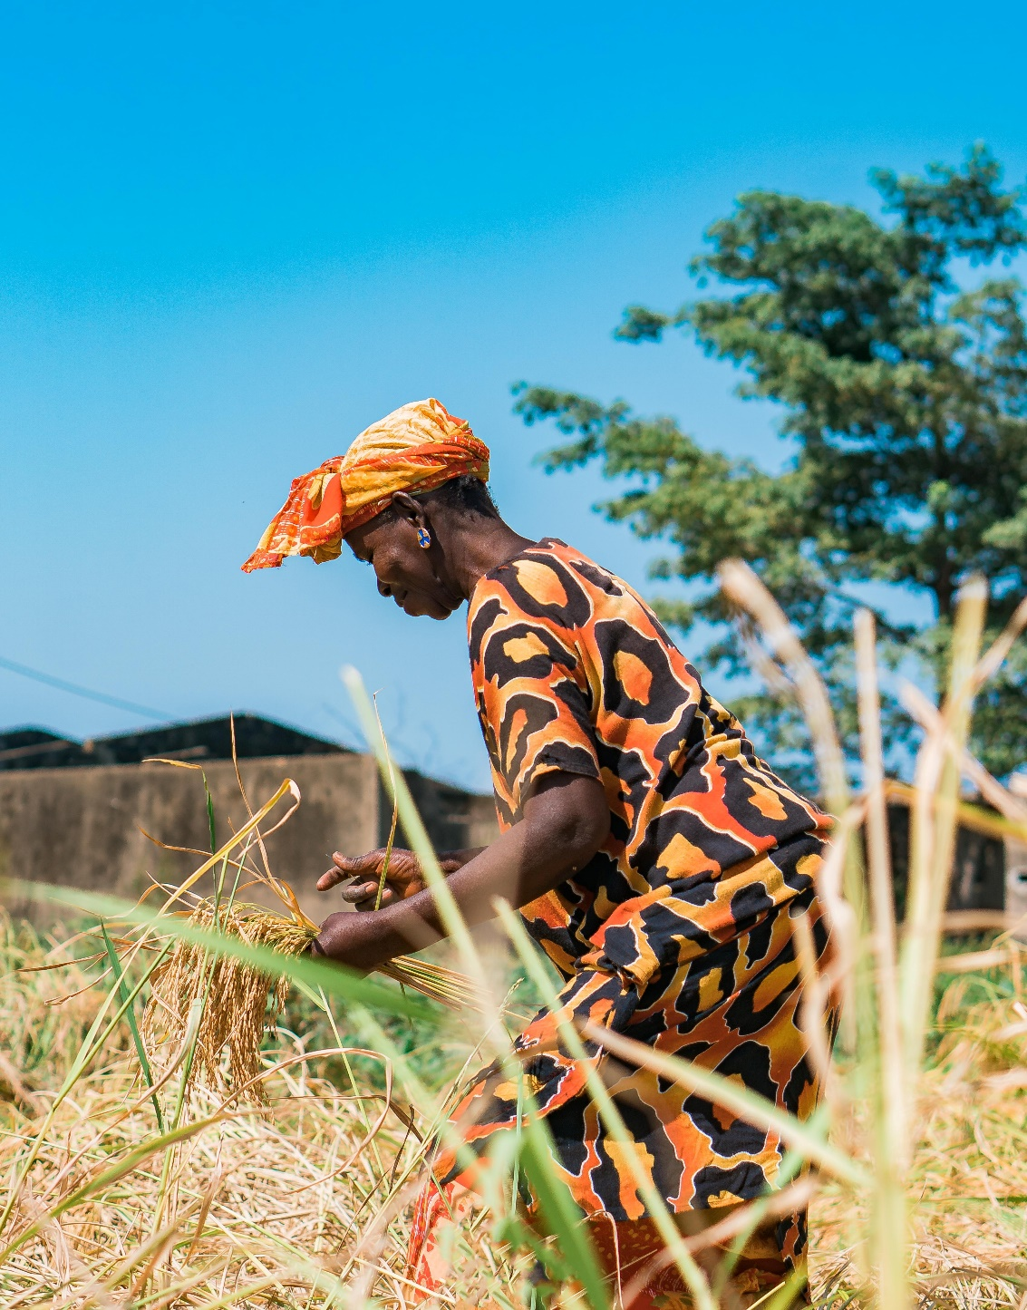
Fulani of Senegal
Fulani pride themselves on being the group that brought Islam across the Sahara to Western Africa.
They are reluctant to leave this heritage behind and renounce Islam to follow Jesus. Senegalese are hospitable, polite, and open to dialogue, and they will quickly listen to the Gospel. However, turning from their own beliefs and practices to exclusively follow Jesus is very difficult. New believers often face persecution and rejection by their families.
Only 0.2% of the 3.9 million Fulani are believers, and there are only a couple of local fellowships among them. There are around 5000 Fulani that reside in Canada.

Pray with us:
Heavenly Father, we thank you for the love you have lavished on us! Please bless the Fulani people with your banner of love.

We long for the Fulani to come into your family, and we call forth their destiny as children of God. Pour out your love on entire families. Bless Fulani marriages to be made whole.

We call forth the new things you are doing. Make a way in the wilderness and let the rivers flow in the desert. We bless Fulani believers who are being persecuted and rejected with great endurance. May they be faithful in sharing your Word despite hardships. Bless the Fulani with a new name, Lord; may they be your beloved, your children! “To the one who overcomes... I will also give him a white stone inscribed with a new name, known only to the one who receives it” (Revelation 2:17). Amen.

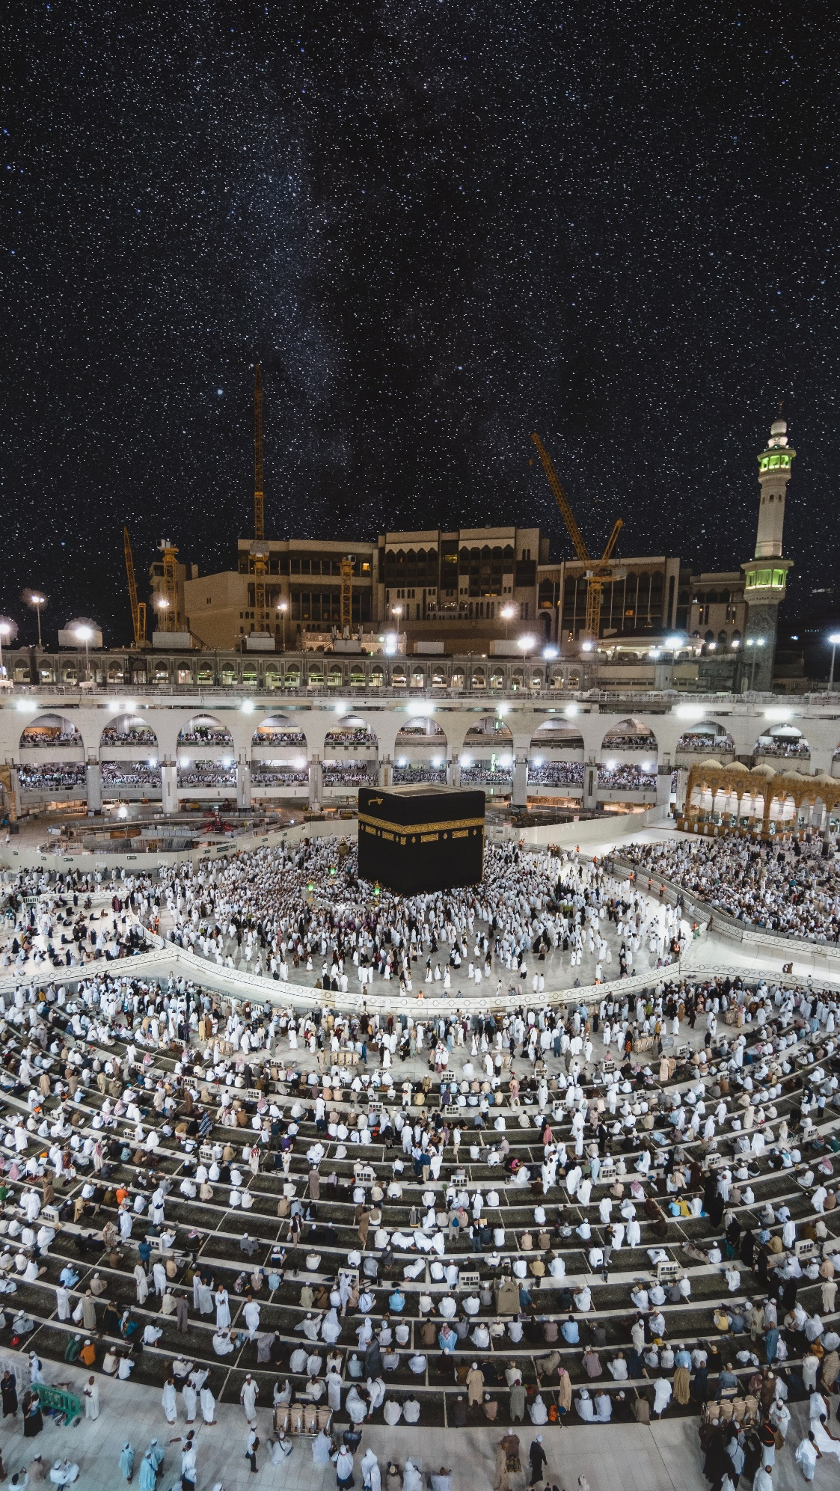
Gulf Arabs
Approximately 54 million Gulf Arabs from Bahrain, Kuwait, Oman, Saudi Arabia, and the UAE. Almost all are followers of Islam except for around 300 known believers. The Joshua Project states that 98.1% of the 78,000 Gulf Arabs living in Canada are Muslim. Many are international students who have travelled to Canada to receive higher education. University is a unique season for many Arab students because they can explore and discover opportunities otherwise unavailable to them back home. Would you consider reaching out to international students and inviting them into your home?

Pray with us:
Father, we bless Gulf Arabs with a disciple-making movement! Bless the few Arab believers with continued favour and opportunities to make your name famous among the nations.
We pray that you would grant your people influence, as you did with Joseph and Daniel. May your people seize divine opportunities to show hospitality to international students. May your love be poured out through your people, into every sphere where they have influence. Bless your disciples with boldness, courage, and the ability to disciple others. “One generation commends your works to another; they tell of your mighty acts” (Psalm 145:4). Amen.

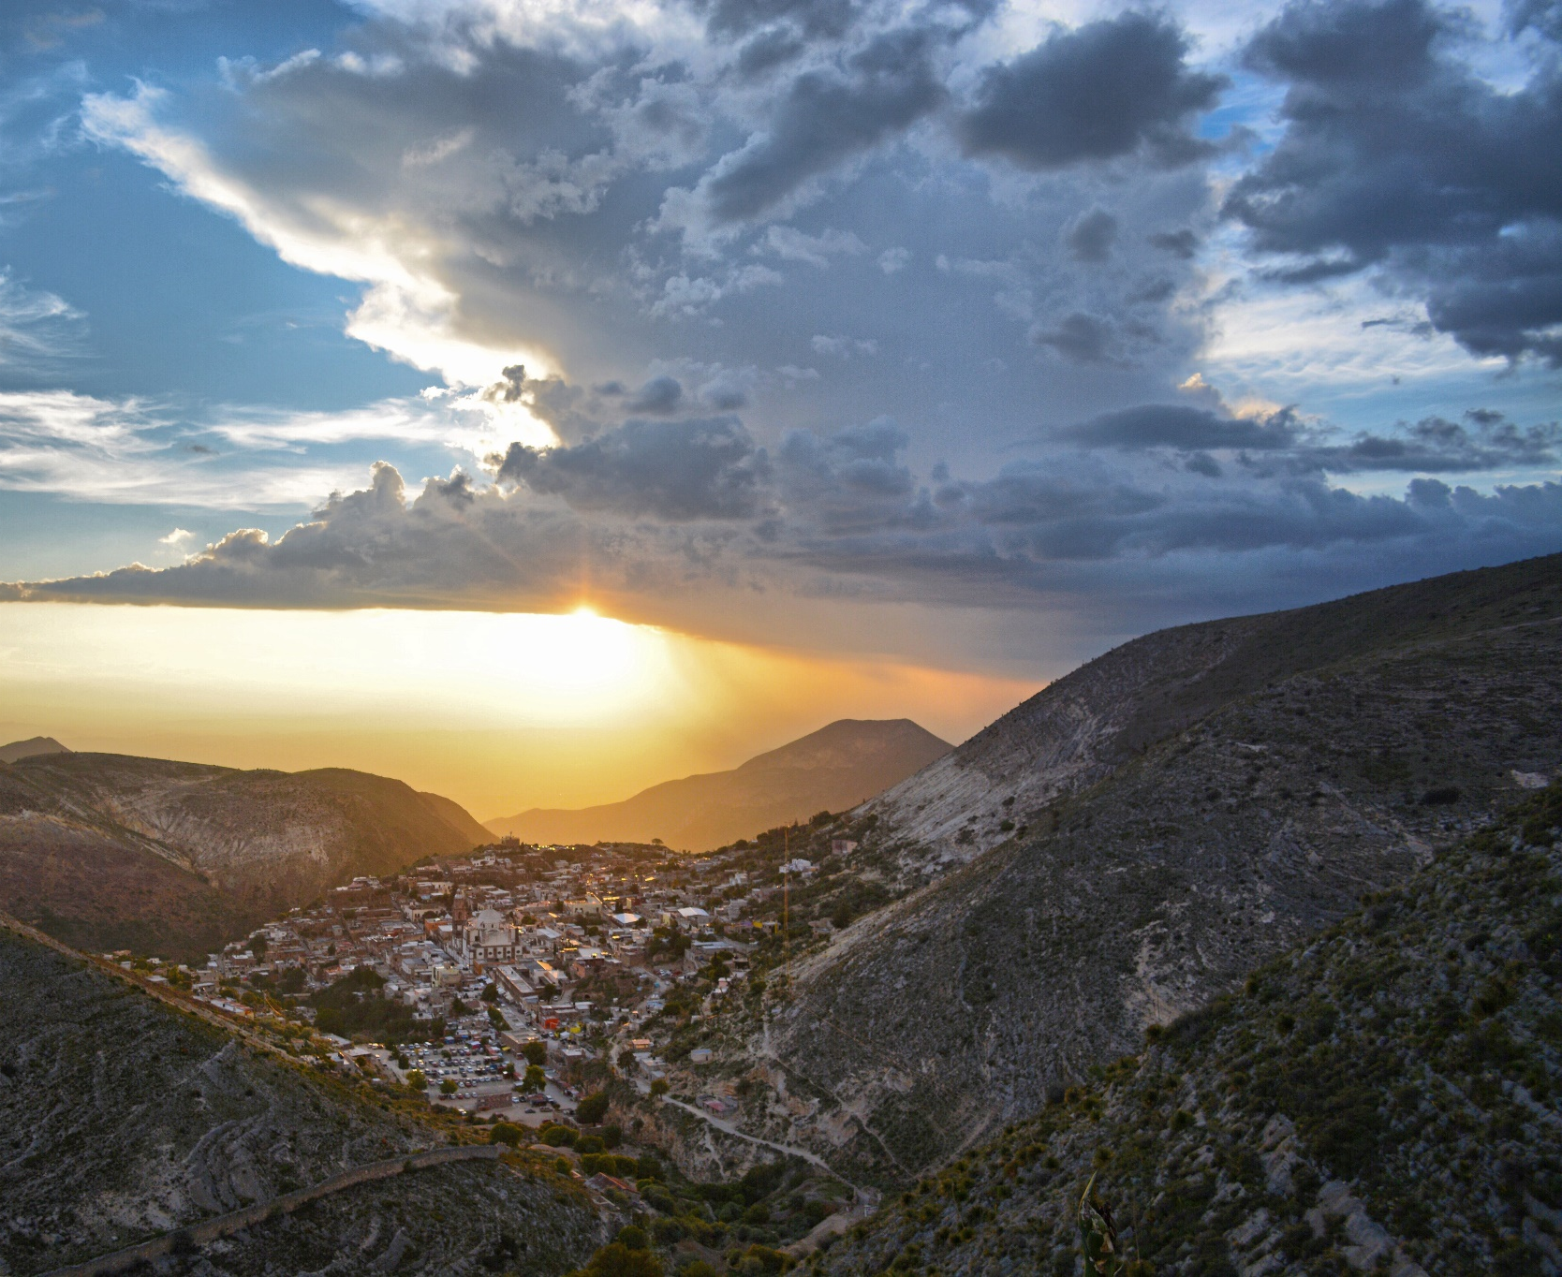
Huichol
Around 44,000 Huichol live in Mexico, and about 6,000 reside in the United States. Only 0.4% of the Huichol population is Christian. Most Huichol follow an ethnic religion that believes in many gods. Converts to Christianity are often persecuted by and expelled from their community.
Praise God that there are new opportunities through community development to build relationships and access other Huichol groups.

Pray with us:
Heavenly Father, please bless the Huichol with the revelation of who you are, the one true God.
Bless them with pictures of your loveliness: a merciful God who saves, a God who rejoices over his loved ones with gladness, and a God who sings over his people. Comfort them with your love (Zephaniah 3:17). May their hearts and minds be receptive to you, Jesus.
We ask for your mercy on those persecuting their people who believe in you. Bless the persecutors with a revelation of who you are and with Damascus Road experiences. Please enable them to see you.
We bless Huichol believers to grow daily in their relationship with you. We pray that through them, you would draw others to Yourself—even to the ends of the earth. Amen.

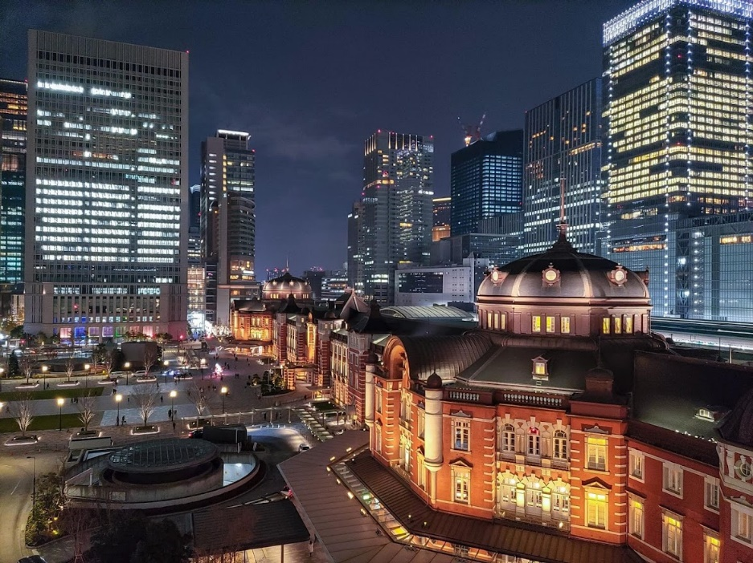
Japanese
Dominated by atheism, Buddhism, and Shintoism, evangelical Christianity represents only 0.5% of the Japanese population. Despite 500 years of Christian presence in Japan, Christianity is regarded as a foreign religion. Over 1,000 cities and half of all the villages have no church. With 126 million, Japan is the largest unevangelized country entirely open to missionaries.
Japan faces many crises. Young people lack hope or confidence in the future; because of this, Japan has a suicide epidemic (over 30,000 per year). High suicide and divorce rates in all age groups confirm the crisis. Economic decline, social isolation, and the constant threats of earthquakes leave many people open to spiritual matters.

Pray with us:
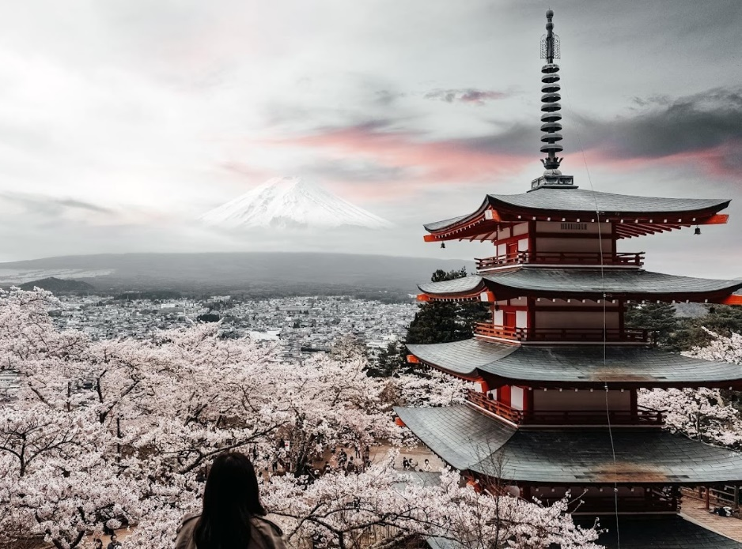
Heavenly Father, would you bless the Japanese with hearts that are open to Jesus. Soften their hearts and let the seeds of the Gospel begin to germinate. We speak life over the people and come against the spirit of death that robs them of hope and eternity with Jesus.
May they hear your voice to them today, to “Come alive!” Penetrate every barrier raised against the knowledge of the Lord Jesus Christ. Increase your Kingdom among Japanese and help them hear the ‘old message’ with new ears and renewed hope.
“For the idols speak delusion; the diviners envision lies and tell false dreams; they comfort in vain. Therefore the people wend their way like sheep; they are in trouble because there is no shepherd” (Zechariah 10:2). Awaken the Japanese from idolatry and bless them with shepherds after your own heart. Amen.

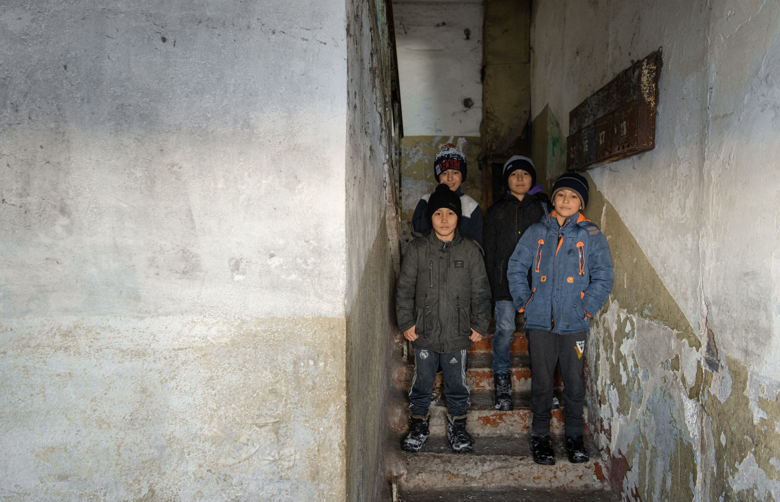
Kazakh
Most of the 12.2 million Kazakh live in Kazakhstan; however, many live in Mongolia, Ukraine, and Russia. About 3,300 Kazakhs call Canada home, according to The Joshua Project. Although many Kazakhs are culturally Muslim, their religion isn’t intensely practiced. Only 0.1% of Kazakhs are Christians.
Kazakhs living in urban areas seem to be more open to hearing the gospel message than those in villages with stronger family bonds. Kazakhs are known for their warmth, friendliness, and hospitality.

Pray with us:
Heavenly Father, bless Kazakhs with a new song! May they sing a new song of praise to you that cannot be silenced! “You are worthy of taking the scroll and of opening its seals because you were slain, and with your blood, you purchased for God persons from every tribe and language and people and nation" (Revelation 5:9).
Pour out your favour and blessing upon the few Kazakh believers to enable them to "each day proclaim the good news that he saves." May they sing of your "glorious deeds among the nations" and "tell everyone about the amazing things" you do (Psalm 96:2-3).
Bless the Kazakhs in these days of turmoil and unrest, with a peace that only comes from knowing the Prince of Peace. May their hearts be hungry for the truth of who you are, Jesus.
Unveil their eyes to the truth of the Gospel, and may their ears begin to hear the whisper of heaven's song saying, "Worthy is the Lamb, who was slain" Revelation 5:12. Amen.

Kazakh Uyghur
The Kazakh Uyghurs live in the world’s largest landlocked country. They border on Russia, ‘the Stans,’ and the western edge of China.
300,000 Uyghurs live in Kazakhstan—most can trace their roots to an immigration wave before the 1960s. They mainly speak Russian and practice Islam. Some may speak the Uyghur language to older family members. Only 0.01% are Christians. One factor that prevents the spread of Christianity is the perception that it is a religion for only the West. Praise God that there are six known Uyghur fellowships in Kazakhstan, ranging from 5 to 30 members.
An estimated 2,000 Kazakh Uyghurs live in Canada.

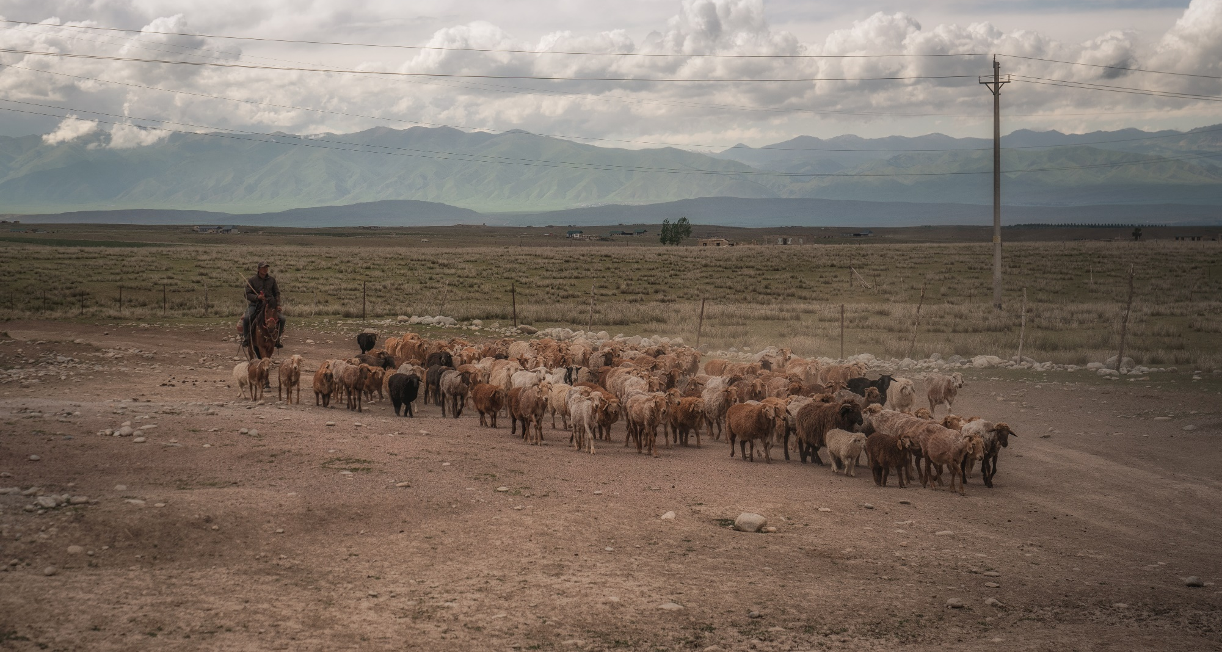
Pray with us:
Lord, will you come with your light and illuminate the pathway to God. Lift the Kazakh Uyghurs from the thick darkness, covering the people. “And he will destroy on this mountain the surface of the covering cast over all people, and the veil that is spread over all nations” (Isaiah 25:7). Bless the Kazakh Uyghurs with open heavens and clarity that they might behold their God, Yahweh, the Creator of humanity. Amen.

Kurds
The traditional homeland of Kurds spreads across Turkey, Syria, Iraq, and Iran. With a worldwide population estimated between 30 – 45 million people, the Kurds are the largest people group in the world without a state. They have a popular saying that “the Kurds have no friends but the mountains.”
Kurds are somewhat receptive to the Gospel, yet only about 1% are Christian; most are Muslim. They are known as being tremendously hospitable and friendly. They have vibrant traditions of telling stories through songs. Kurds are also known to be fiercely independent and patriotic. Their society is strongly communal and is arranged according to tribes.
Many Kurds seek a better life in western Europe, North America, and Australia. About 7,400 live in Canada.

Pray with us:
Heavenly Father, we pray that Kurds would receive the friendship of God and know Jesus. Bless them by giving them faithful Christian friends and continue to grant them revelations of Jesus in miraculous ways. We pray Hosea 2:23 over them that you would call them your people and be their God.
Bless them to discern what is true and be dissatisfied with anything false.
May Kurds come to be your people and spread your fame. Bless them by meeting them in their needs, as they call upon you for help. Amen.
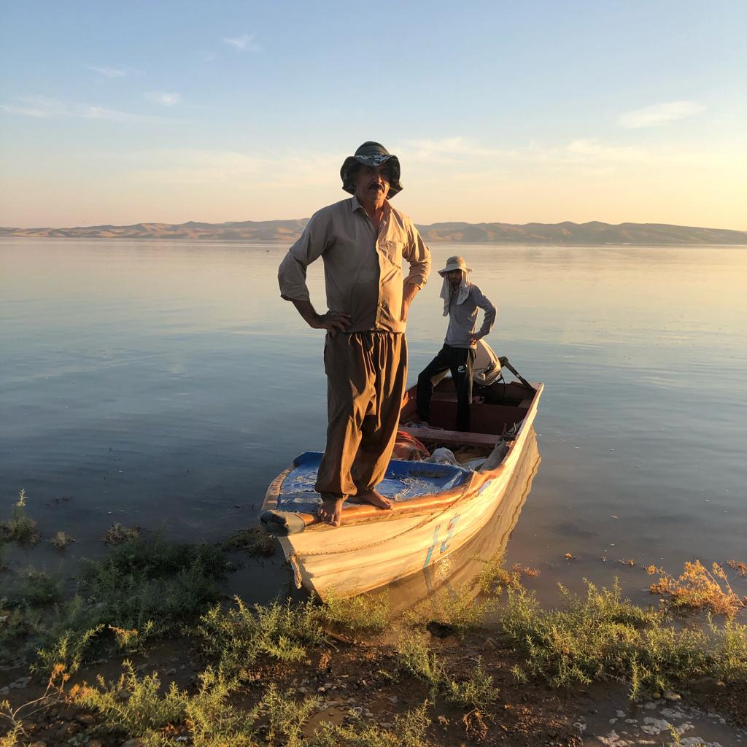

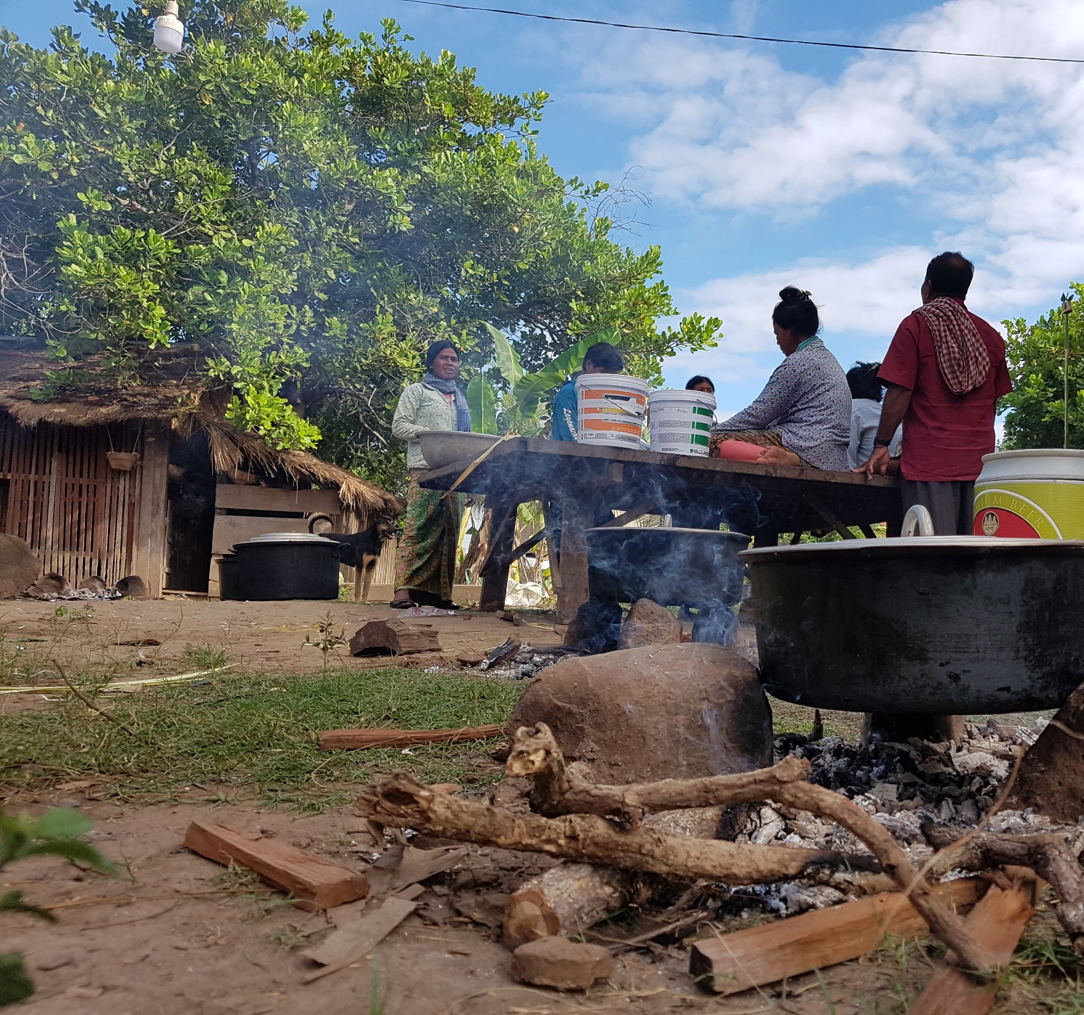
Kuy
The Kuy inhabit both sides of the Thai-Cambodia border, with about 35,000 living on the Cambodian side. They are predominately animist in their belief, with Buddhism mixed in. The Kuy are deeply steeped in their religion, but they are not entirely resistant to Christianity. Only 0.53% of the Kuy are considered Evangelical Christians, but there are several small Kuy churches in Cambodia.
The Bible has recently been translated into Kuy, and we trust that they will soon have a greater interest in reading it. May those who follow Christ boldly proclaim their faith!

Pray with us:
Lord, would you magnify the uniqueness of Jesus—the One who does not share his glory with another, the One who provides a sure and certain way to salvation, the One who has overcome all antagonistic spiritual forces and, as One with God, rules over the cosmos. May the Kuy see you for who you are!
Bless Kuys with a revelation of the uniqueness of Jesus and discernment to wade through their belief system, testing it against the purity of your Word. Bless them with a hunger for truth. Would you favour them with a solid and growing confidence in Jesus? Come, and love these people into your fellowship, Jesus. Amen.

Laotian
There are over 7 million Laos, and 60% identify as Buddhists. Animism, religion, and folklore are deeply rooted in the Lao culture. According to The Joshua Project, 2.52% of the population are Evangelical believers.

Pray with us:
Heavenly Father, would you help the Lao know the blessing of their God-created culture. Bless them to see where they have entangled and robbed of their freedom in Christ.
Holy Spirit of God, hover over this nation. Give them a deluge of truth that will unseat tradition and bring release. Bless them with living water to refresh them and lead many to salvation.
Thank you that you will present the Lao before Yourself as a pure and spotless bride. We lift these prayers of blessing to the Eternal, whose love for the Lao is never failing. Amen
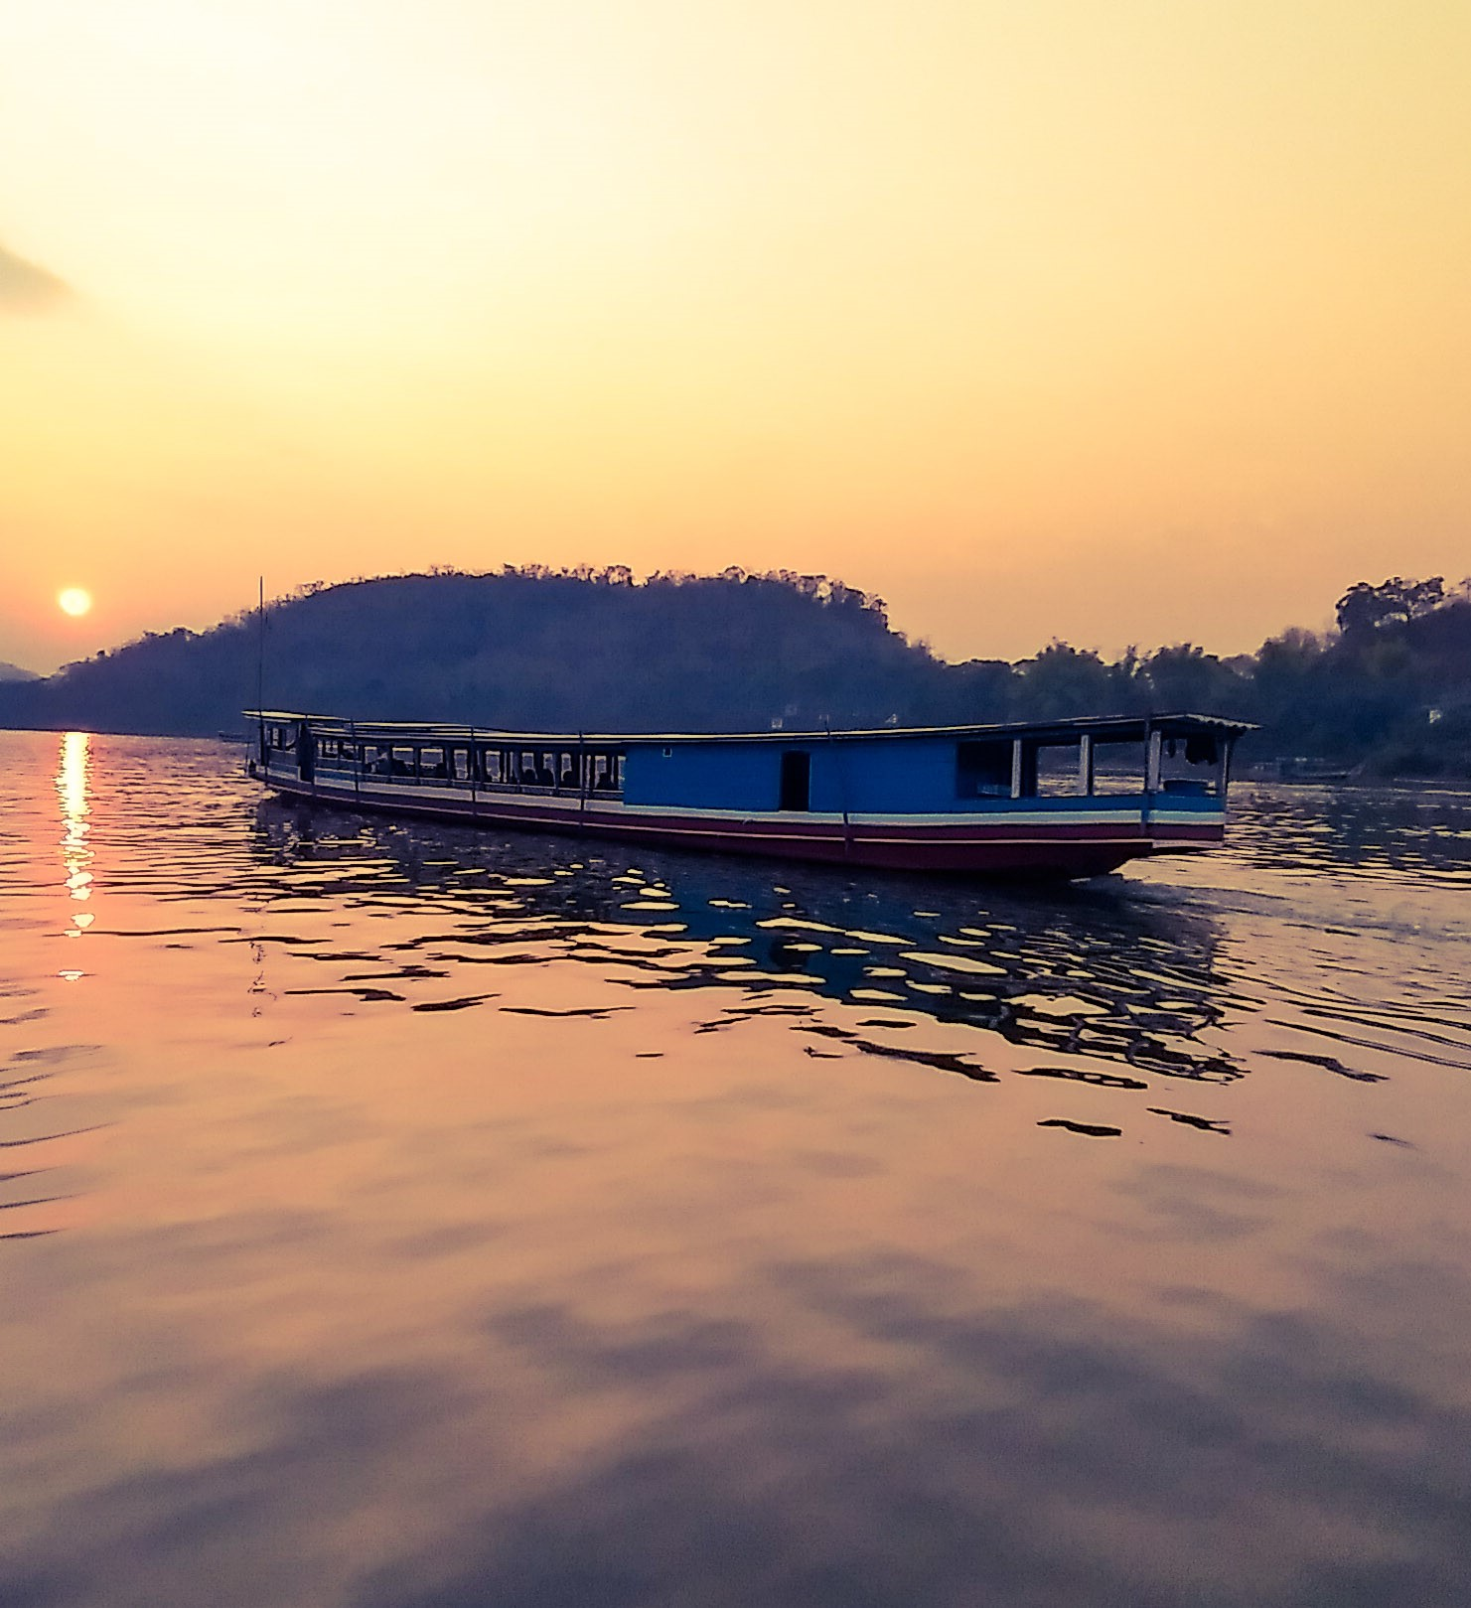

Minnan
Worldwide there are 58.2 million Minnan. 13.4 million Minnan call Taiwan home. The majority religion of Minnan is a mix of Taoism, Buddhism, folk religion, and ancestor worship. Evangelical Christians make up 3.7%. Many Minnan believe that all religions are the same. They are reluctant to follow Jesus if it means forsaking ancestor worship because filial piety is central to Taiwanese culture.
The Taiwanese work very long hours. They prioritize education for their children, and most elementary school students go to cram schools after school.
Approximately 14,000 Minnan Chinese live in Canada. Pray God would work in the hearts of the Minnan living both here and abroad!

Pray with us:
Our Lord, you are the one who opened blind eyes. Would you bless Minnan people with the awareness that what they long for in the depths of their being are you and your salvation? Grant them sight to see you. Open their spiritual eyes to envision God’s plan for their lives and see themselves as worshipers of the One true God.
Show them the risen Jesus in all his glory. Light of the world, break through the darkness, causing every lie to fall, and bless them with visions and dreams of the Saviour of the world. May all praise, honour, and glory be to you! Amen.

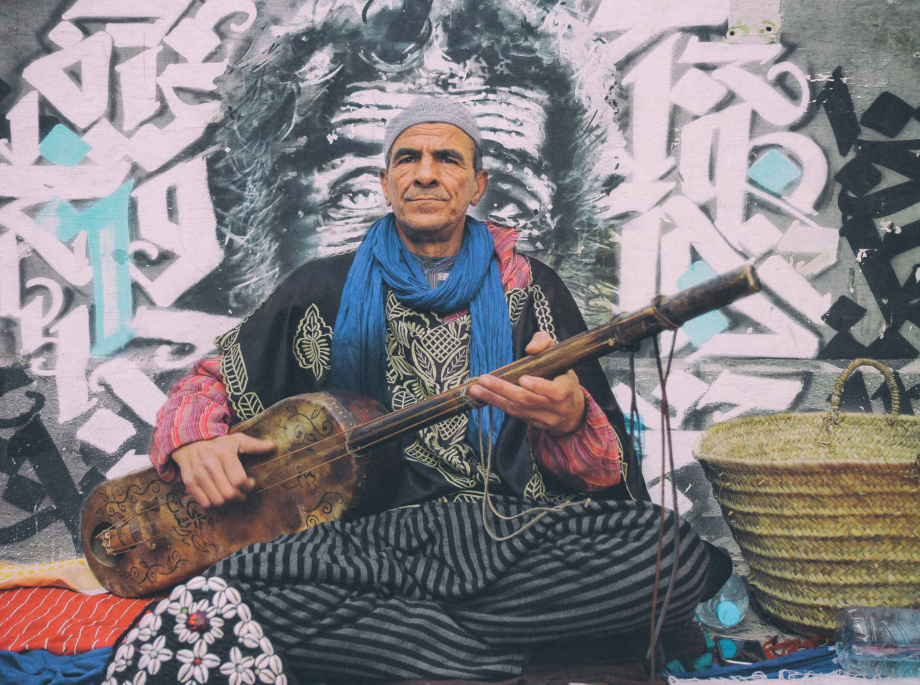
North African Arabs
Over 252 million North African Arabs live in seven different countries. Some North African countries have no fellowships, while others have local fellowships with a higher percentage of Christians. The evangelical population in this region ranges from 0% to 0.39%. Depending on the location, receptivity to the Gospel varies from low to hostile.
Warm and hospitable, with a strong emphasis on family and relationships, many North African Arabs have also found themselves in Canada.

Pray with us:
Father, we bless the communities of faith among North African Arabs with an anointing of your Spirit. As they go out, fill them with boldness and courage. May they share your love and truth. Father, thank you for how North African Arabs mirror the hospitality you have shown. We bless North African Arabs with hungry hearts, ready to receive the truth of Jesus Christ.
Come and speak to them through dreams, visions, media, and local believers. You stand at the door and knock. May they hear your voice and open the door so that you can come in. May they eat the Living Bread, drink the Living Water, and be satisfied. We bless those currently searching for you to find more than they ever imagined. Amen.

North Africans in Spain
Many North Africans have moved to Spain. The province of Barcelona has a large Muslim population of 135,000. In one international worker’s town, 10% of the population is from North Africa—of whom 1% are believers with no local fellowship.
Our international workers in Spain regularly share gospel stories with them. Some have begun to join weekly prayer and worship meetings. In that town, the people are mainly Berbers and Arabs, who enjoy Chinese tea with mint and lots of sugar. They are incredibly hospitable people, and a visit can stretch over two or three meals.
More than 325,000 North Africans live in Canada.

Pray with us:
Father, we bless North Africans with hope and a future! We pray that many will know your goodness. We declare your sovereignty over the nations, and we bless them with the everlasting hope that changes everything.
Thank you for marking out their appointed times in history so that they would find you. Father, as North Africans travel and meet people, would you set people who know you in their path. We pray that your people would offer hope to North Africans. We ask that we feel your tender heart and compassion for them. Amen.

Pashtuns
Pashtuns have a reputation as independent and fearless people. They are also known for their love for children, close-knit families, and rich literary history of poetry and proverbs woven skillfully into daily discourse. They are lavish in their hospitality and generosity to guests. Their clothing and textiles are expressive and filled with brilliant, striking colours and patterns.
There are approximately 40-45 million Pashtuns, mainly in Afghanistan and Pakistan. The Joshua Project suggests about 47,000 Pashtuns call Canada home. Less than 0.1% of this people group are Christian. Typically, the Gospel is met with resistance and hostility by Pashtuns.

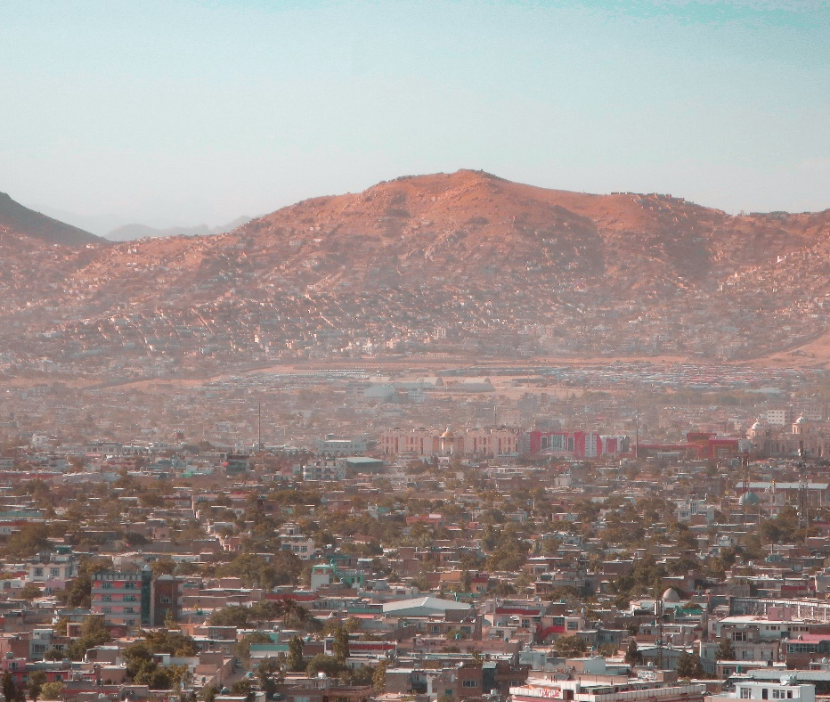
Pray with us:
Lord Jesus, thank you for how warm and hospitable Pashtuns are. You welcome us with your arms open wide, and we pray that you will bless many Pashtuns with that warm embrace.
We know that you are watching each of them and that you long for them to come home to you. Bless whole households and tribes with dreams and visions. Lead them to gospel witnesses who will introduce them to your warm embrace.
Bless the few Pashtun believers to grow in faith and resilience despite persecution and suffering. Bless them with miraculous Kingdom breakthroughs among all the Pashtun tribes. Amen.
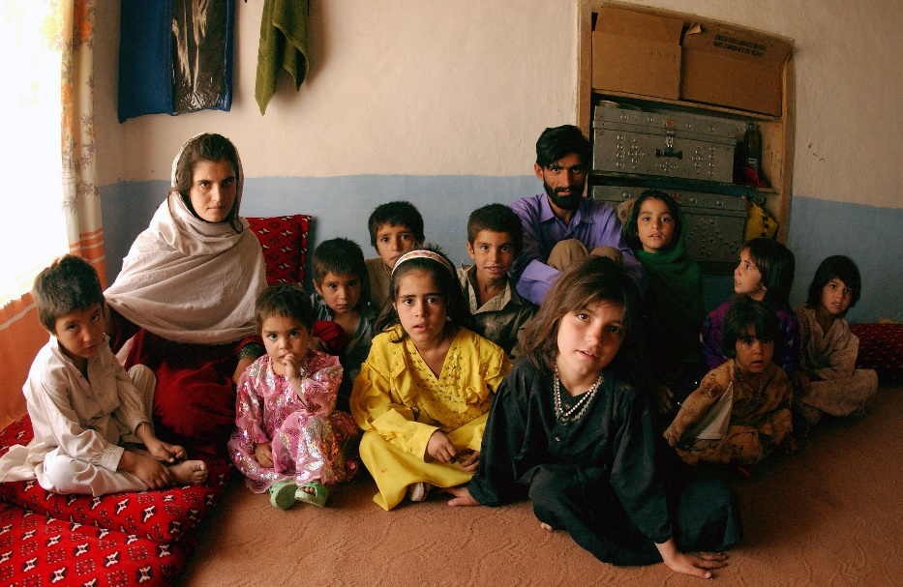

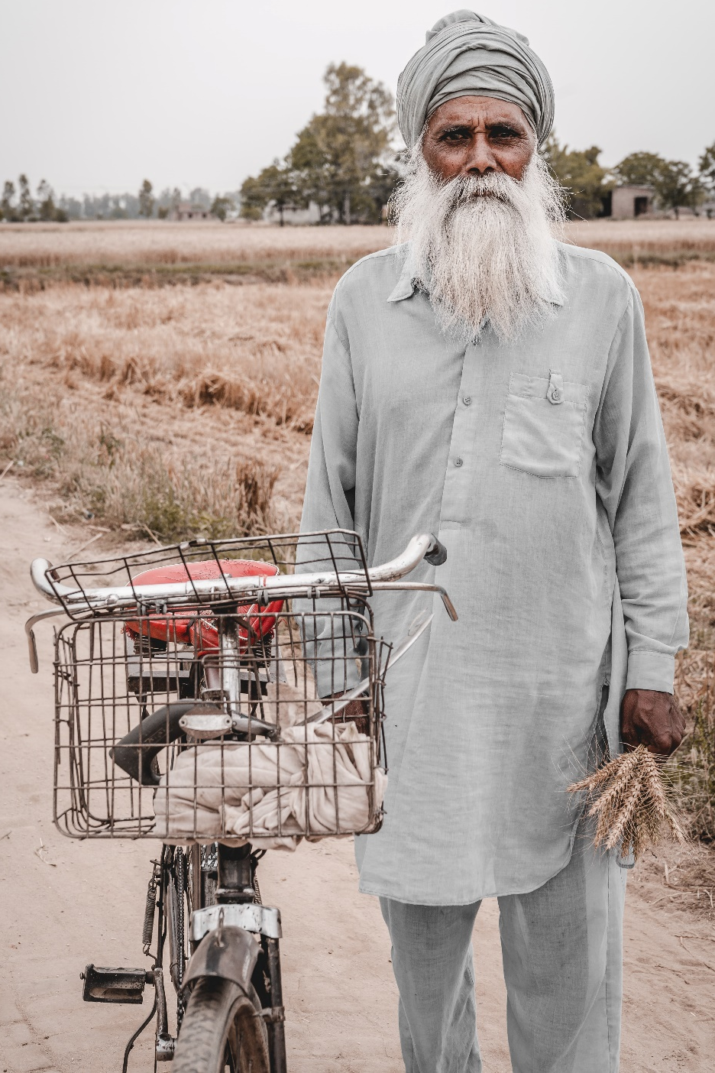

Punjabi Arain
There are 0.0% Christians reported among the global population of 9.9 million Arain. The Punjabi-speaking Arain mainly live in the northern Indian state of Punjab. They are almost all Muslim.
Over 500,000 Punjabi people are living in Canada.

Pray with us:
Father, we rejoice in the day when the Punjabi-speaking Arain will discover the face of their Creator. What a glorious day it will be when the hearts of the Arain are reunited with their Maker!
Stir the hearts of your people with a desire to reach the Arain. We ask that Arains would have a deep yearning to know you and be known by you. Pour out your Spirit upon entire families. Holy Spirit, we ask that you continue to soften their hearts, prepare them to recognize you, and be reunited with the One who loves and cares for them.
As the seeds are planted, would you bless the soil of our friends’ hearts to receive their King? We bless the roots to grow deep and for the seeds to receive the nourishment and care they need so that a fruitful harvest may come. Amen.

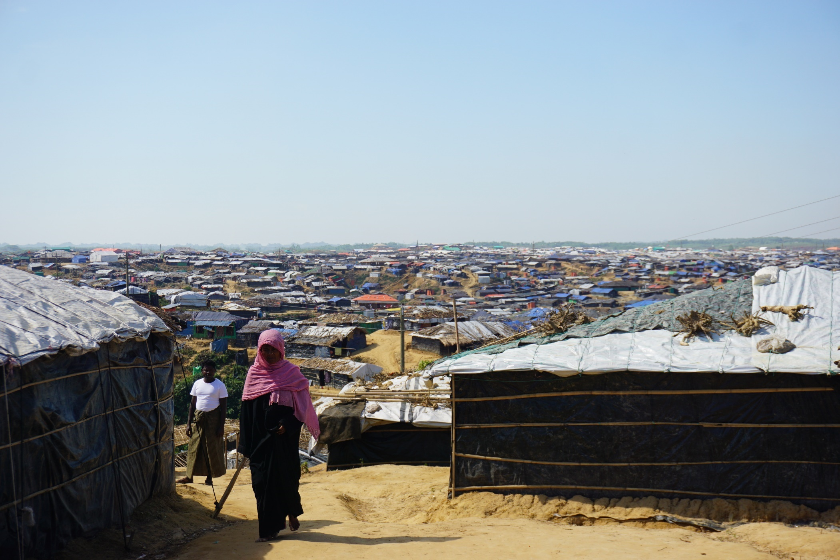
Rohingya
There are at least 2 to 2.5 million people in the Rohingya—of which less than 20% still live inside Myanmar.
The rest have left the country and gone abroad. Over 700,000 Rohingya have settled in large refugee camps in Bangladesh.
Even though most Rohingya are Muslims, there is growing receptivity to the Gospel. Rohingya Christians are still less than 1% of the population. Yet, it is encouraging to know that there is a small number of secret fellowships in the camps.
Approximately 2,000-3,000 Rohingya live in Canada, many in the Kitchener-Waterloo, ON area.

Pray with us:
Father, we pray that you would bless the Rohingya with a new name—their God-given identity.
They are no longer forsaken, forgotten, or rejected. They are made in your image, and we declare that they are the beloved, seen by you, and chosen to know the Saviour.
We ask you to bless them with vigilant, vibrant, and caring Christian communities around them in Waterloo and everywhere they have had to relocate to.

As you have added to the number of believers, would you add to them the deepening love and understanding of your ways? Amen.

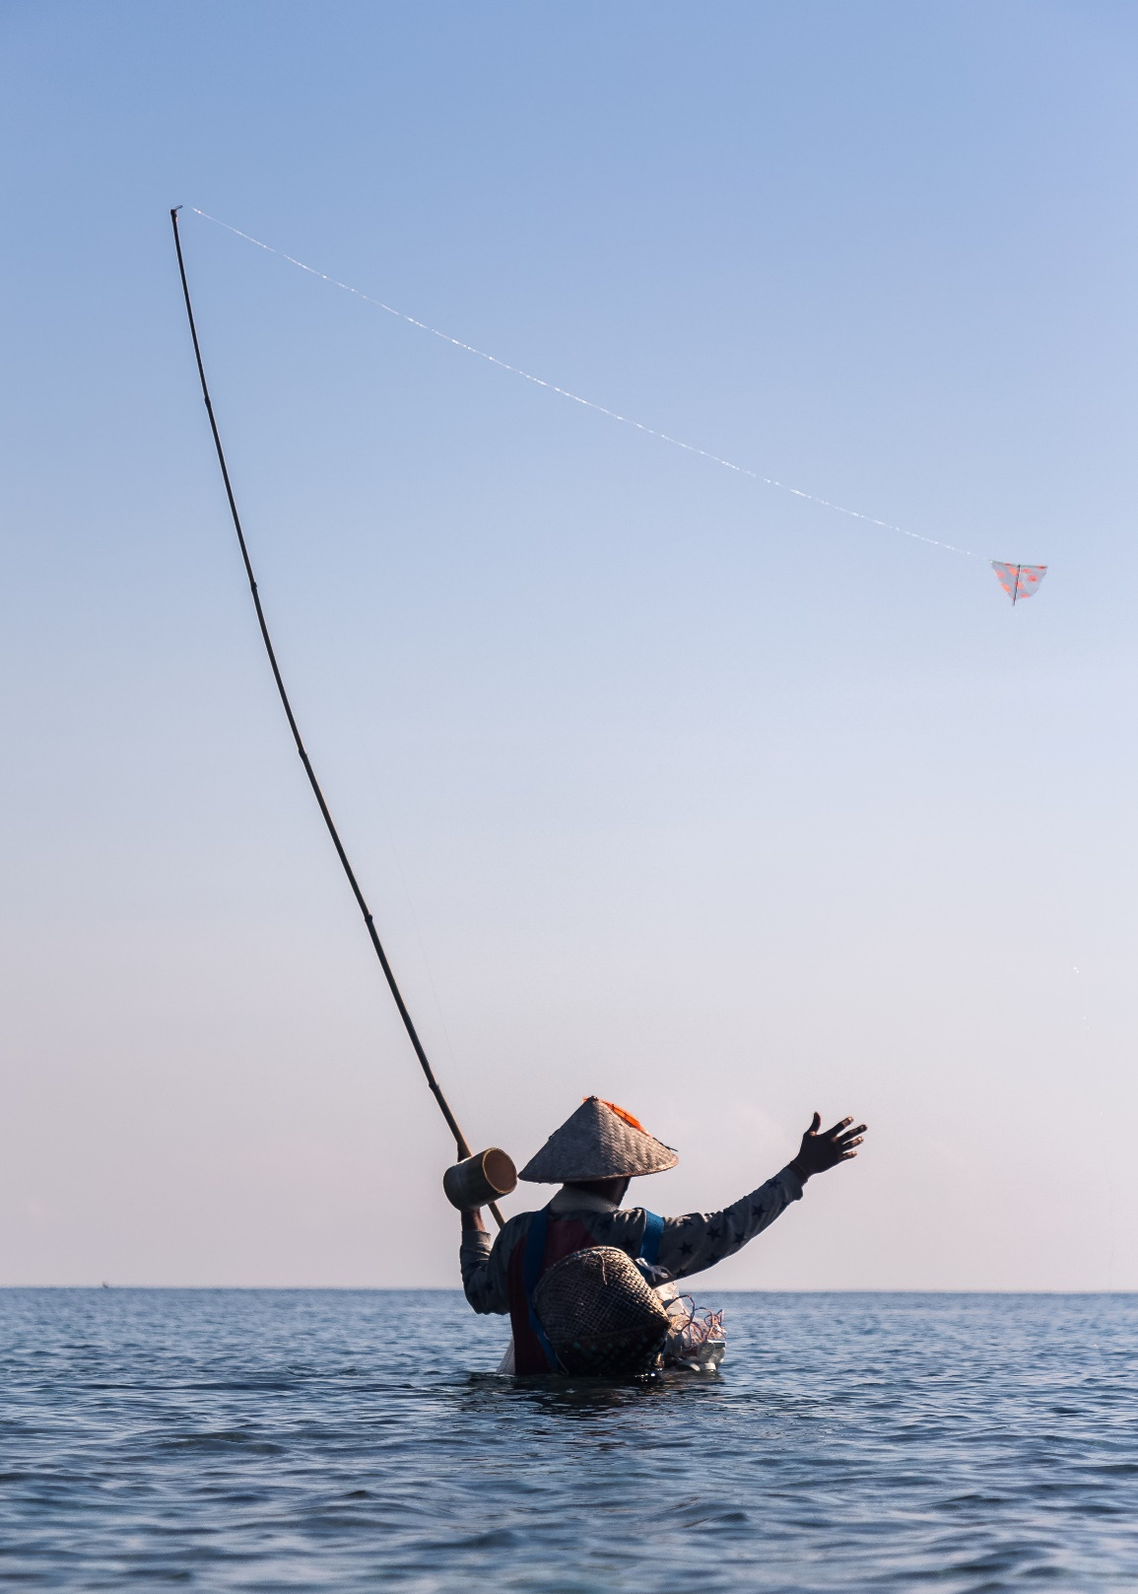
Sasak
Islam is the main religion of the 3.3 million Sasak who predominately live in Indonesia. Only 0.01% of Sasak follow Jesus.
Sasak typically work as farmers, fishers, and artisans. In Sasak culture, family life is fragile because of high divorce rates. When getting married, many Sasak follow the custom of eloping. The woman voluntarily allows herself to be “kidnapped” and “hides” while the “kidnapper” negotiates the wedding terms with her family. After the terms are set, the wedding ceremony follows.
Many Sasak are traumatized by frequent earthquakes, floods, poverty, high maternal mortality rates, and child mortality.

Pray with us:
Father, we thank you for your amazing love for the Sasak. Soften their hearts so that they would understand their need for you. Bless them to know you as their Savior, Sanctifier, Healer, and Coming King.
Beckon them to Yourself, Jesus, and draw them into the intimacy of relationship with you. We ask that they receive an invitation to the wedding supper of the Lamb. Bless them with eternal salvation, we pray. Amen.

South Asian Diaspora
Highly collectivistic and communal, over 5 million South Asians work as labourers in the Arabian Gulf: Indians, Pakistanis, Nepalis, Bangladeshis, and Sri Lankans. The majority work and live in extremely demanding conditions while remitting up to 80% of their poverty-level earnings to their loved ones back home. Yet, they are hospitable and generous with guests, exemplifying a spirit of resilience. There are many Christian fellowships among Indians, with over 10% believers. However, less than 1% of the other countries represented are believers, with very few Christian fellowships. The Muslim host culture is not receptive to the Gospel to the point of rejection and hostility.
Around 2 million South Asians live in Canada.

Pray with us:
Father, we bless South Asians in the Arabian Gulf. We ask that they are treated justly and fairly in their workplaces. Satisfy them with your rest. Give them a deep understanding of your great love for them. We ask you to bless them with dreams and visions to show that you are a good Father.
We bless them with open hearts to the flood of your mighty love. We pray Muslims would have open eyes to see Jesus as the ultimate expression of your great love for them.
May they come to understand that you deeply care for and desire them. Come Lord Jesus and soothe their wounded souls. Let love’s grip dissolve their reserve, woo them, and draw them into your goodness. Amen.

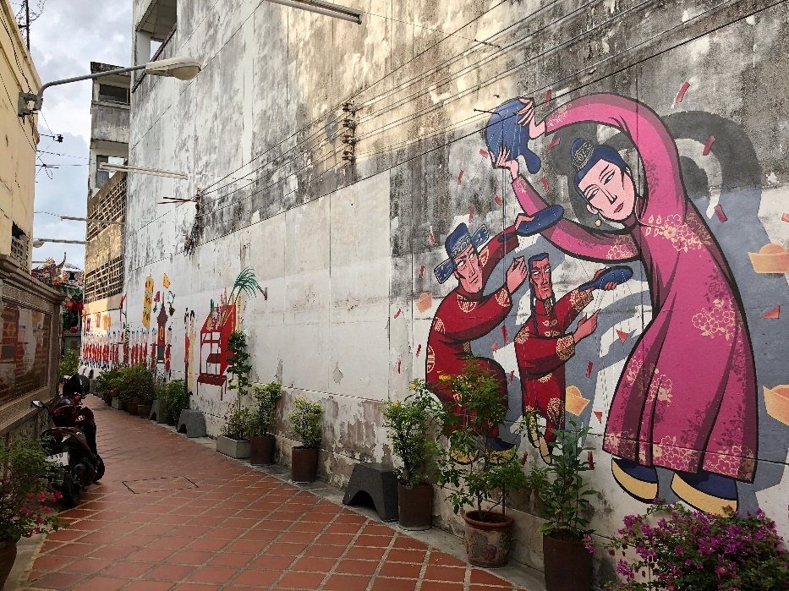
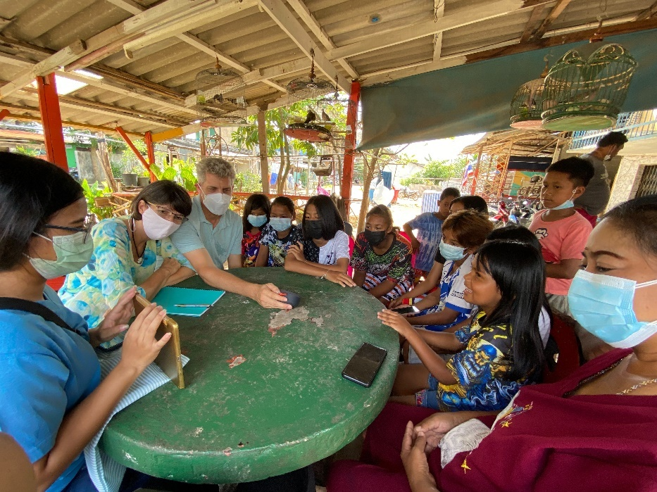
Southern Thai
Although the main religion of Thailand is Buddhism, Islam is the predominant religion in Southern Thailand. Most Southern Thai practice a folk Islam mixed with animism.
Many people in Southern Thailand are Malay by descent, who ended up in Thailand when Britain and France established the country’s borders in the early 1900s. Of the 10 million people who live in the south, less than 0.5% are believers, mainly from Buddhist backgrounds.
Locals believe a particular city in this region has intense spirit activity. Many people travel there from other countries to make merit and appease the spirits.
About 20,000 Thai call Canada home and the vast majority are Buddhist.

Pray with us:
Father, bless Thailand with a tremendous outpouring of your Holy Spirit! Thank you for the workers you have already called there! Bless them with protection, courage, and wisdom as they follow you into the ripe harvest fields. Would you send even more labourers to Thailand? We pray for connections with people of peace who both receive and share the Gospel with their friends and neighbours.
Bless many Thai with hearts that respond to your Good News. May the nation of Thailand yield a harvest of righteousness for the glory of your name! Amen.

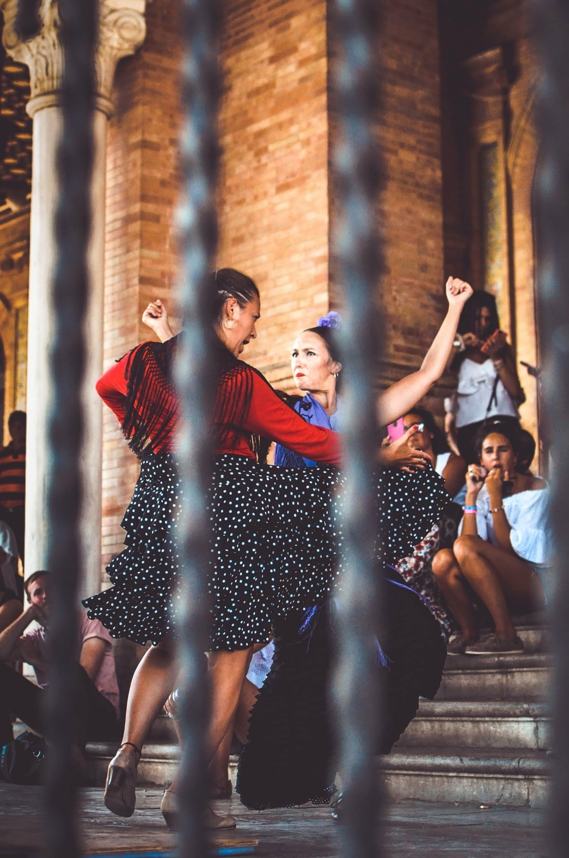
Spaniards
Roman Catholicism is the main religion of the over 47 million Spaniards, but there are rapidly rising levels of secularization. Atheism and Islam are the fastest-growing belief systems. Receptivity to the Gospel has been very low, and less than 1% of Spaniards are evangelical Christians. Ten million Spaniards live in towns without any evangelical presence.
Praise God there are 28 Alliance churches and fellowships in Spain. Two of them have between 100 and 200 members; the rest vary between 20 and 100. Most local fellowships meet in warehouse spaces, storefronts, and homes. Unlike much of Europe, the Protestant Reformation did not penetrate Spain due to the Inquisition. The Moors (Muslim inhabitants of the Iberian Peninsula) ruled Spain for 800 years, leaving a lasting impact on language, architecture, education, crops, and cuisine.

Pray with us:
Heavenly Father, bless Spain by increasing the number of faithful workers. As your workers make disciples who disciple, would you add to the numbers of those being saved? We pray that the people of Spain would recognize and acknowledge the King of Glory.
Open the gates of the cities, the businesses, the homes, and the hearts of Spaniards. King of Glory, come, bless, and draw the people to you. We pray the people of Spain would recognize their King, The King of Glory, Jesus! Amen.

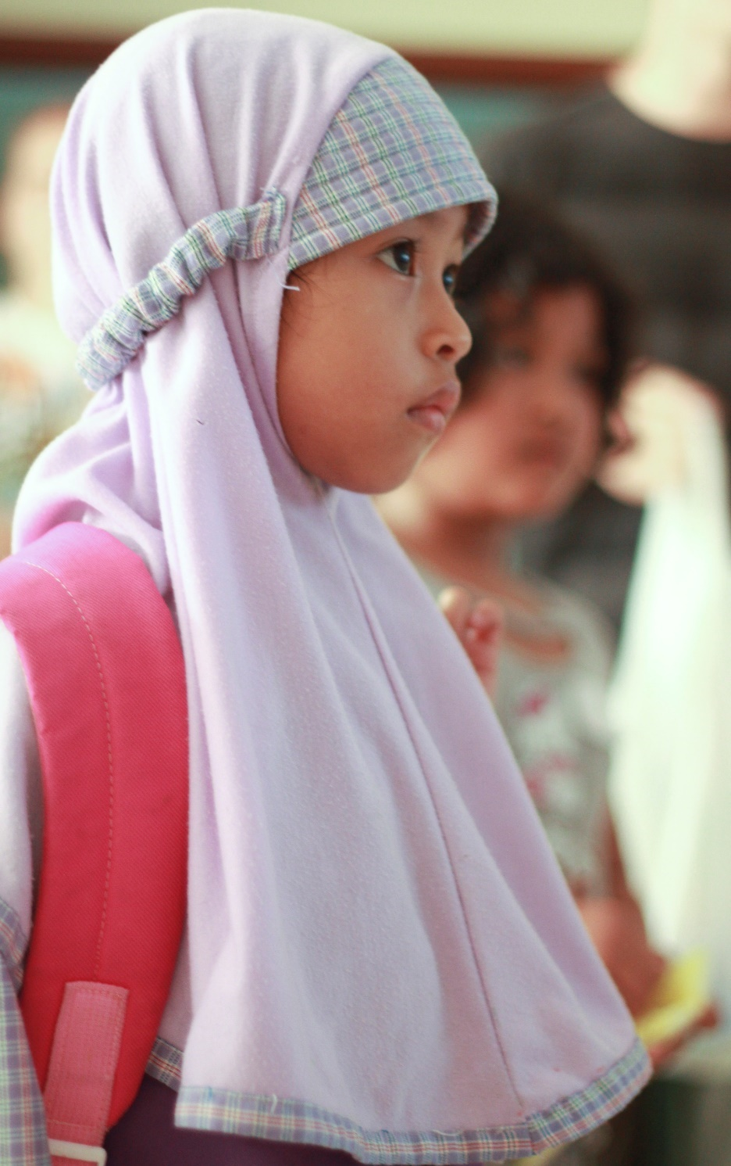
Sunda
The majority of Sunda live in Indonesia, and their culture is rich with celebrations of life cycle ceremonies. They are the largest least-reached people group in Indonesia. Of the 38 million Sunda, only 0.05% are evangelical Christian. Most Sunda are devoted followers of Islam, with many added traditional customs. Historically, they have been unreceptive to the Gospel, though the Spirit is moving in new ways!

Pray with us:
Holy Spirit, we ask that you breathe your life into the hearts of our Sunda friends. We prophesy to the dry bones and call them to come alive!
Thank you for these ripe harvest fields! Please bless them by sending out more workers. May the Sunda hear the Good News with soft hearts to receive your message. Bless the believers among them with fellowship, and multiply your work among these people. Lord, pour out your Spirit! Amen.

Tajik
The Tajik make up 84% of Tajikistan's population, 25% of Afghanistan's, and 5% of Uzbekistan's. There are 18-25 million Tajiks globally. 98% of Tajiks are Muslim, and less than 0.01% are believers. There are only a few local fellowships and house churches among them.
The international workers introduce Jesus to Tajiks by first sharing the stories that Islam and Christianity share: Creation, the Fall, Abraham, Noah, and Moses. Family roots are deep. Obedience and submission to the family keep people from following Jesus openly.
Tajiks are renowned for their generous and welcoming hospitality. They seat their guests in places of honour, furthest away from the door, feeding their guests first and their children last. About 1 million Tajiks work abroad, primarily in Russia, to send remittances to families. Approximately 2,400 Tajiks call Canada home.

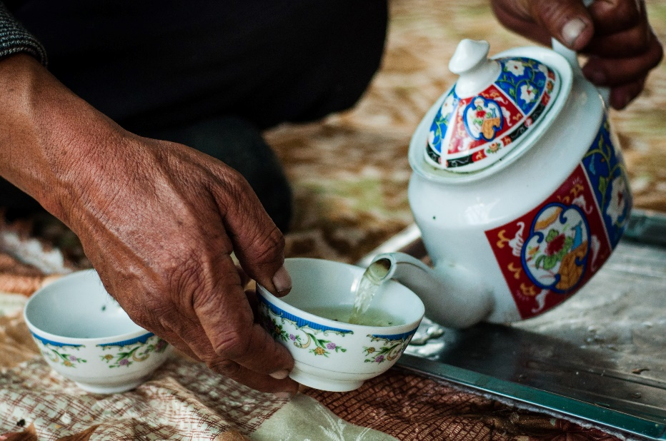
Pray with us:
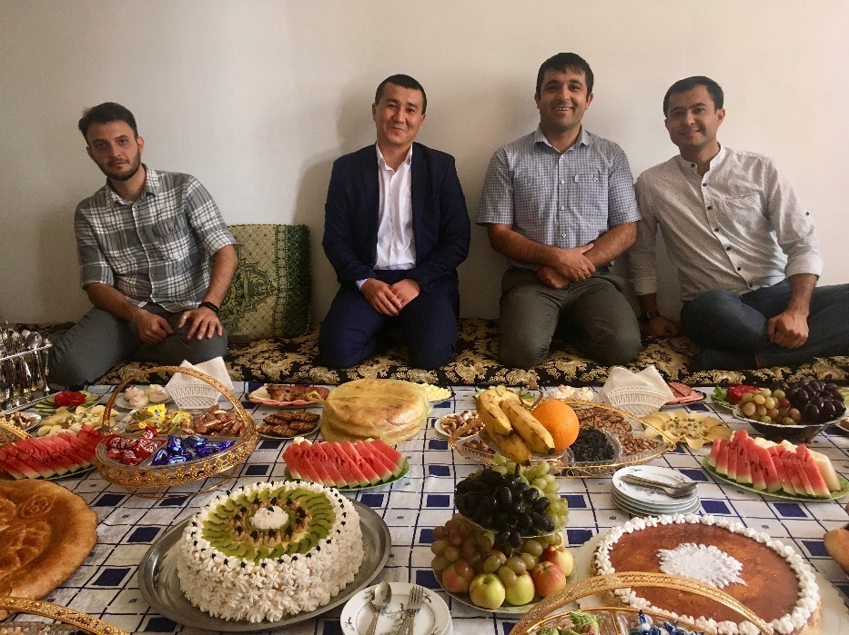
Jesus, we thank you that you are the way, the truth, and the life. We bless the Tajik to know the truth and for the truth to set them free. May they know freedom from all shame as they receive your forgiveness. As they come to know you, Jesus, bless them with honesty and purity in their innermost being. Would you call them to the identity of children of God in harmony with the Creator? Would you satisfy their inborn desires for a love relationship with you? Revive their longings for all that is good and satisfy them with rest. We ask that you bless Tajiks with the peace of a secure identity in you. Amen.

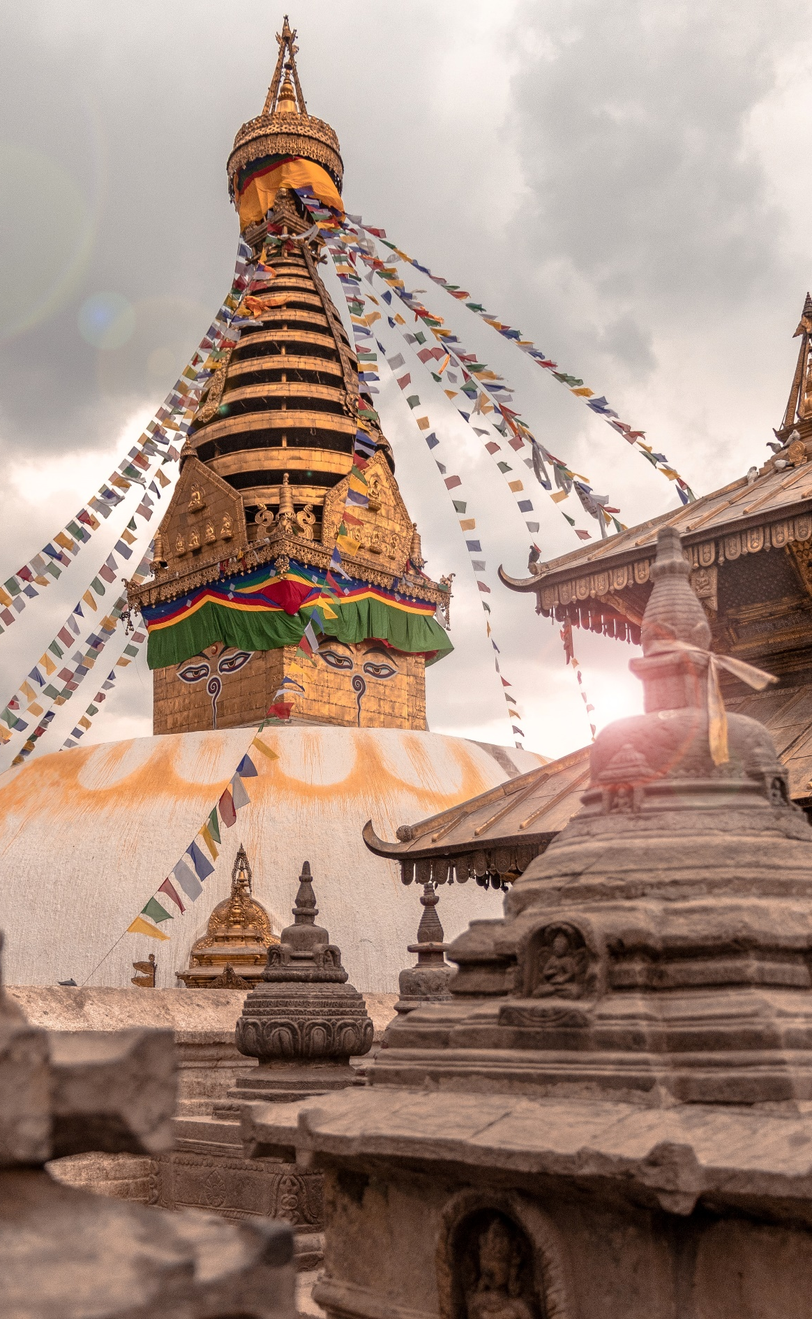
Tibetan Refugee
Most Tibetans live in Western China, India, Nepal, and Bhutan. In 1959, over 80,000 Tibetans fled their homeland for India and Nepal. Since then, over 150,000 Tibetans have moved abroad and created diaspora communities in North America, UK, Germany, France, Switzerland, and Australia. About 9,600 people of Tibetan descent live in Canada.
Most Tibetans practise Tibetan Buddhism (a mixture of Buddhism and the indigenous, shamanistic religion of Bon). Most Tibetans hold the belief that to be Tibetan is to be Buddhist. An estimated 0% of Tibetans are Evangelical Christians.
Although receptivity of the Gospel has been very slow, around eight small fellowships meet online. Those who become Christian seem to develop into strong leaders who greatly desire to share Jesus with their community.

Pray with us:
Father, we commit ourselves to be the hands and feet of Jesus to Tibetans as they come to Canada. Grow our love for you so we may follow your commands to love. Just as you have been generous to us, God gives us generous hearts towards Tibetans. Lord, you provide for the stranger, the fatherless, and the widow, and when we join you in it, you bless the work of our hands.
Jesus, would you lead Tibetans to salvation and give them the joy of your presence. Let the refugee diaspora find their solace in the salvation of the God who, alone, is our refuge. Amen.

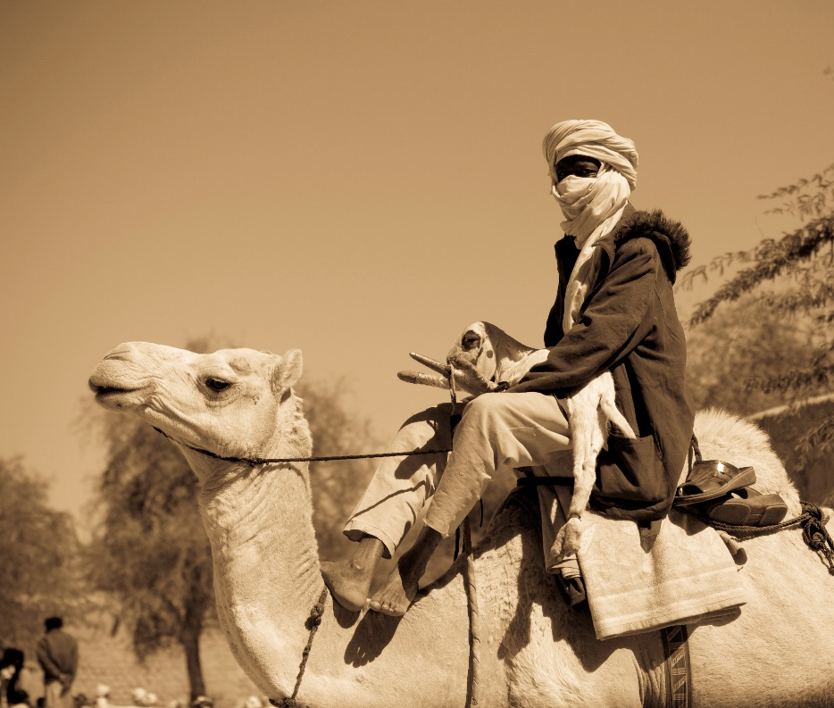
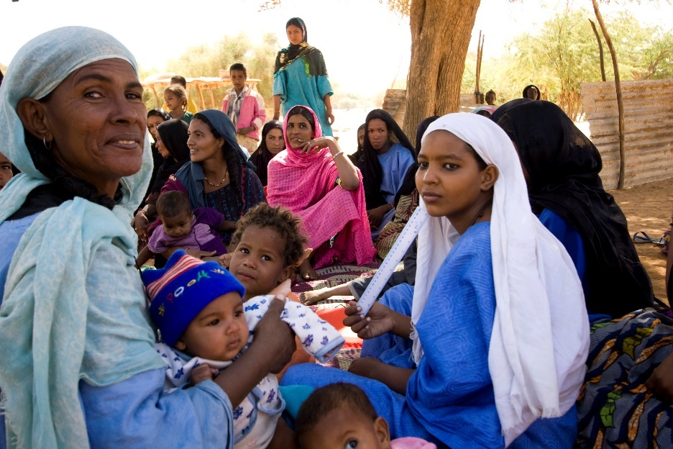
Tuareg
Founded under Queen Tin Hinan, the Tuaregs are traditionally monogamous, semi-nomadic herders and warriors. Tuaregs are called the “blue people” of the desert due to their indigo-coloured clothing, which stains their skin. They are also known as the “veiled ones,” since men wear turbans. Tuaregs have their traditional script called Tifinagh, and different regions have their traditional crosses, used as a charm for protection against evil.
In Niger, their population is 2.6 million, though there are possibly only a dozen Tuaregs in Canada. Islam is the main religion, and there are only a handful of scattered local fellowships among the Tuaregs. New believers face being ostracized from all family members, including forced divorce if married. Audio and oral Bible teachings play a vital role among the largely illiterate Tuaregs.

Pray with us:
Father, we praise you for the vibrant culture you have given Tuaregs. As seeds are sown through audio and oral Bible teachings, we bless them with open hearts to receive your Gospel. Thank you for calling the Tuaregs to be free. We bless them with Holy Spirit’s presence. Bless them with complete freedom in Christ. We bless Tuareg believers with humble unity and a deeper life in Christ.
May Tuareg Christians be a witness to those around them that many would know of your love. Amen

Turks in Germany
5-7 million Turks reside in Germany. Many immigrated to Germany as labourers in the 1960s. Most Turkish communities live in urban industrial centres of West Germany. Although most originate from Turkey, there are also significant ethnic Turkish communities from all over the Middle East.
Culturally Sunni Muslims, the majority have become secularized. However, it is difficult for individuals to turn to Christ because they are perceived as forsaking their family, heritage, and culture. Conversion brings great shame to their families, and they face tremendous pressure to stay true to their families. Although there are very few Turkish Christians, 40 small fellowships are scattered across Germany.
Around 64,000 people of Turkish origin live in Canada.

Pray with us:
Heavenly Father, we thank you for the many Turks that you have brought to Germany for your purposes. We speak an evangelistic blessing over the German Church to make disciples of all nations. We pray that the German Christians and the ex-pats would, in unity, bring the love of Christ to their Turkish neighbours.
Jesus, bless the 40 Turkish fellowships with an outpouring of your Spirit. Strengthen them to be apostolic, prophetic, and evangelistic disciples who train new believers to live missionally. Please bless Turkish believers with the boldness to share the Gospel, and we ask that you accompany the message of Christ with signs, wonders, and healings. We ask for a move of your Spirit that would cause whole families and networks of families to turn to Christ. Amen.

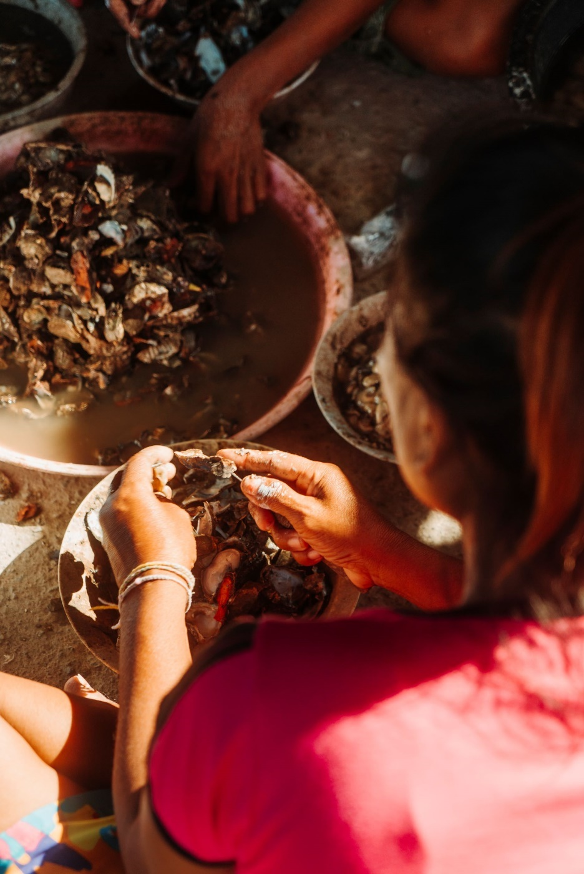
Urak Lawoi
Urak Lawoi (pronounced: oo-rak lah-woi) means “Sea People,” Their way of life is genuinely linked to the ocean. Since migrating to Thailand from Malaysia by boat many generations ago, the Urak Lawoi communities have sustained themselves fishing. The men weave nets, build traps, and dive for fish, while the women collect shellfish in low tide. They are a family-oriented people concerned with preserving their traditional way of life amidst the threat of decreased fish populations (loss of traditional jobs) and increased globalization. Because of this, they hold tightly to their religion, a mixture of animism, ancestor worship, and Buddhism. They are open to the Gospel, but few decide to submit to Christ based on the customs of family and culture.
There are no known Urak Lawoi outside Southern Thailand.

Pray with us:
Our Loving Lord, would you bless these people with messengers of the Gospel who will live lovingly among them and share their lives, becoming part of their community. Immanuel, God with us, live through your ambassadors in meaningful and powerful ways as they come alongside the Urak Lawoi. Let the song of the Lord arise from an ever-increasing community of faith. Bless them with a new song on their lips, with praise to their God. Amen.

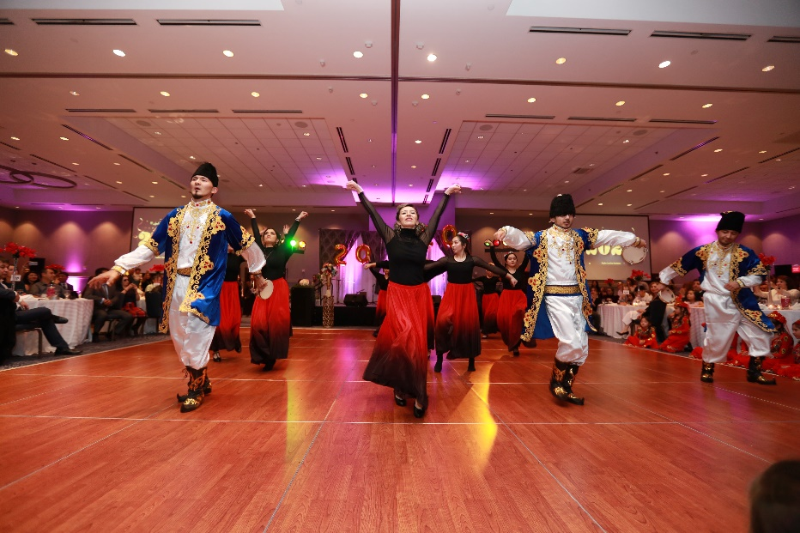
Uyghur
Most Uyghurs, about 12 million, live in Northwest China. A small number live in the Central Asian republics with a combined 300,000. Of these populations, 0.01% are Christians. It is hard to know the extent of Christianity due to present persecution. Local fellowships are scattered and have gone underground. Most of the population is disinterested, resistant, and opposed to the Gospel as they struggle to hold on to their culture and religion.
The Uyghur are a Turkic people group who are hospitable and love music and dance. Their community celebrations are always lively! These joys have been limited by the increasing restrictions on their religious and cultural practices.
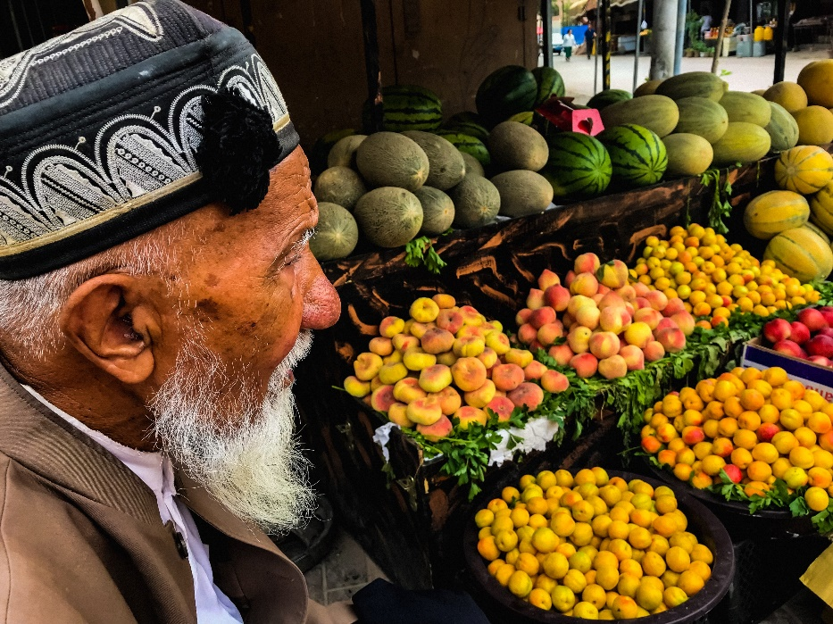
Canada is home to 2,000 Uyghurs.

Pray with us:
Almighty God, thank you for designing and creating the Uyghurs to express your glory. Would you bless them with courage and tenacity to sustain them through present trials? We pray that the advance of the Gospel will not be impeded. May they call out to Yahweh during the current persecution. In their terror, would you meet them as the eternal God of love? Bless them with justice, with opportunities to hear the Gospel, and scheduled encounters with Jesus during this time of suffering. May our Christian brothers and sisters remain firm in their faith and share your hope with these struggling people. Hear the cries of your creation and bless them with peace. Amen.

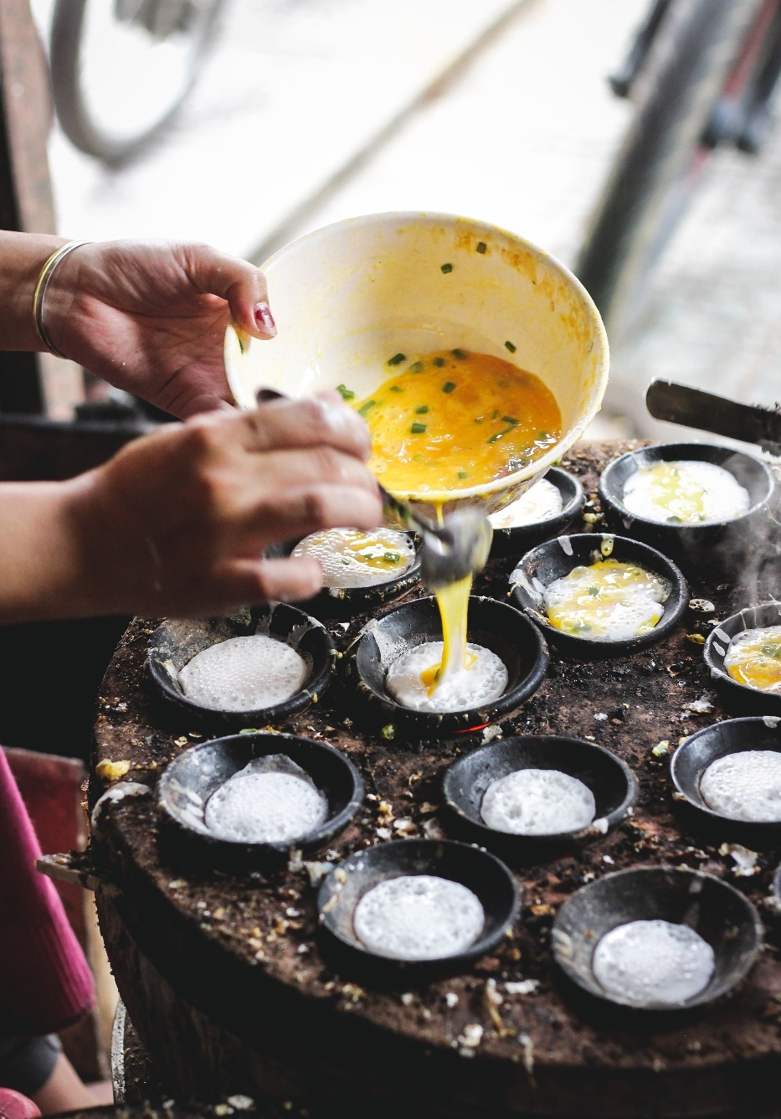
Vietnamese Diaspora in Cambodia
Approximately 800,000 Vietnamese live in Cambodia—38.5% of whom are under 20. Most are undocumented migrants, materially poor, and many are illiterate or pre-literate.
As undocumented migrants, they face many struggles trying to find stable income and access to education. They experience hardship as an immigrant population embedded in an unwelcoming society.
Most practice a mix of Buddhism, animism, and ancestral worship. Only 0.17% of the Vietnamese in Cambodia are Evangelical Christians. There is a growing church presence in Phnom Penh and a few other areas, but there is little to no gospel access in most other regions of the country.
There are over 240,000 Vietnamese who call Canada home!

Pray with us:
Father, thank you for those you have called and sent to work among the Vietnamese. Bless them with wisdom from above and encourage them daily. We pray that you would raise leaders from the local body of believers to serve. Bless and anoint those you have sent to preach among the Vietnamese. Would you remove every obstacle that stands in the way and bring down any strongholds rooted in religious traditions? Bless the Vietnamese with the ability to hear and believe so that many will call upon the name of the Lord and be saved! Amen.

Western Fulani
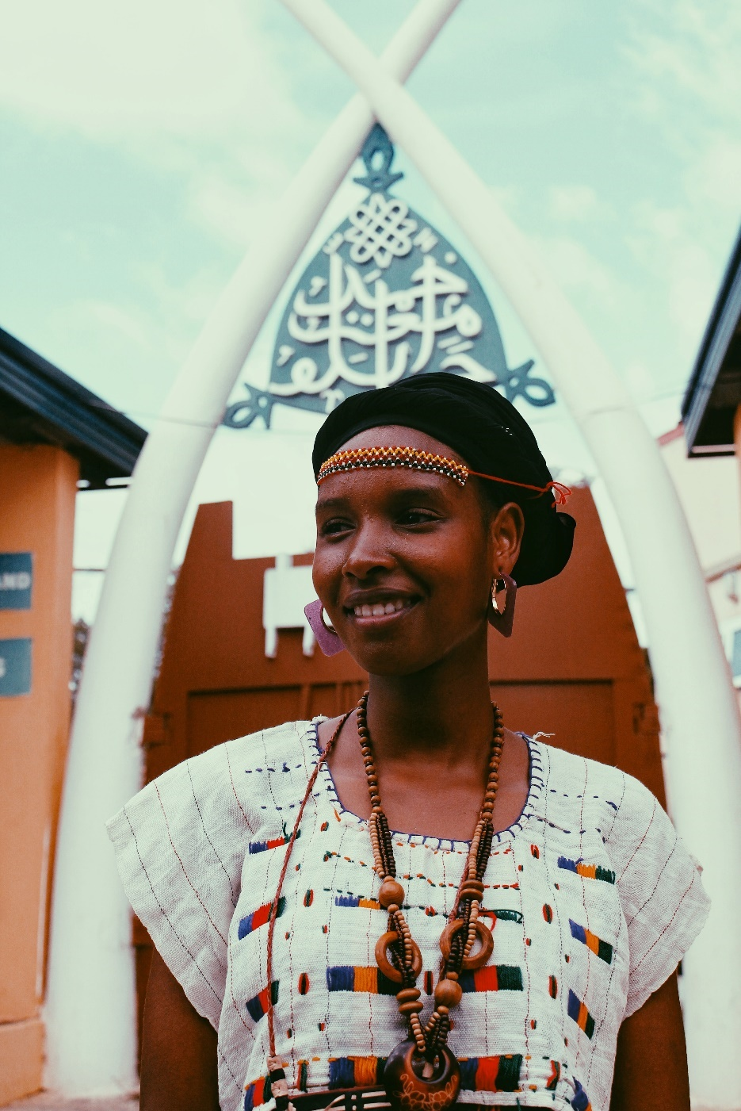
Most of Niger’s Western Fulani are poor, illiterate, rural animal herders marginalized by neighbouring people groups. While most Fulani are no longer nomadic, they still take pride in their cultural history. In some villages, the young men travel hundreds of kilometres on foot every year, leading their cattle to pasture and water.
Fulani values include hospitality, patience, reserve (stoicism), and respect. They practice folk Islam, and their life is guided by an unwritten but extensive system of rules that dictate family, social, and religious interactions.
Of a population of 1.2 million Fulani in Western Niger and 2.5 million globally, the percentage of evangelical believers is only 0.01%. Some Western Fulani live in the city attend church. There are a few small fellowships that a national believer is leading. About 5,000 Fulani live in Canada, but they are primarily from other countries, not Niger.

Pray with us:
Father, we bless the nomadic Fulani, those wandering in desert wastelands to be led by a straight way and be gathered in. We bless those living in bondage to fear and religion brought forth from darkness and the shadow of death.
Deliver them from the distress of their sinful ways and heal their afflictions. May they cry out to the Lord so that the thirsty ground of their hearts would be turned into pools of water. Bless them that they would be wise and attend to the Word of the Lord. Bless the Fulani to sing praises of your steadfast love forever! Amen.

Wolof
The Wolof have strong ties to their culture, heritage, and language. Despite colonization, modernization, and globalization pressures, the Wolof still maintain many traditional practices.
There are around 6,000 Wolof who call Canada home, and they have predominately settled into communities in Ottawa, Montreal, Quebec, and Winnipeg. Only 0.02% of the 6 million Wolof are Christian; the rest are followers of Islam. Most Wolof are not overtly antagonistic to the gospel message.
They are usually polite and will “discuss” Christian views but are still resistant to follow Jesus wholeheartedly.

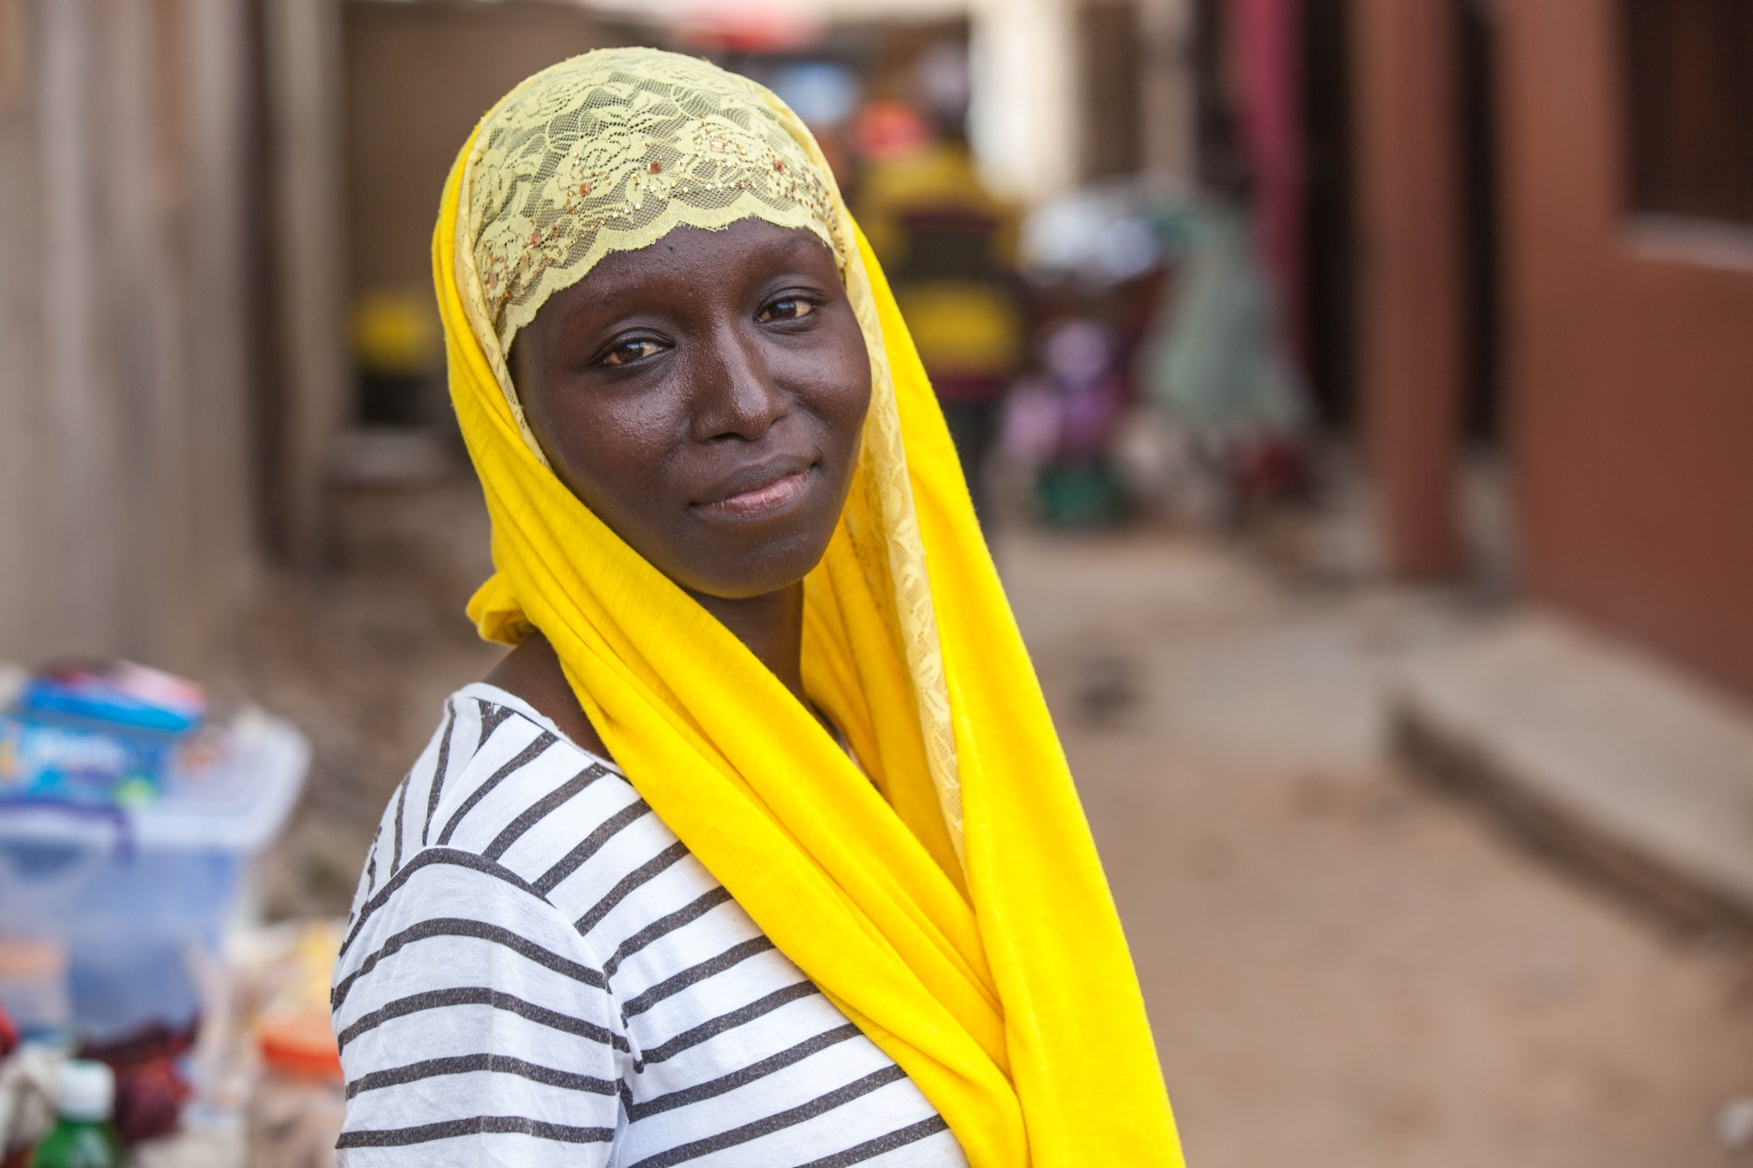
Pray with us:
Lord Jesus, you are the Prince of Peace. You are peace to the heart amid fear. We thank you for Wolofs who have found you as their peace. For those who do not know you in this way, we pray that you will bless them with the peace that comes from a relationship with Jesus. Bless them with the assurance of eternal life. We ask that you uphold new Wolof believers and keep them faithful to Jesus and firm in their faith, despite persecution and rejection by their families. Enfold them in your garments and speak the hope of peace to their understanding. Amen.

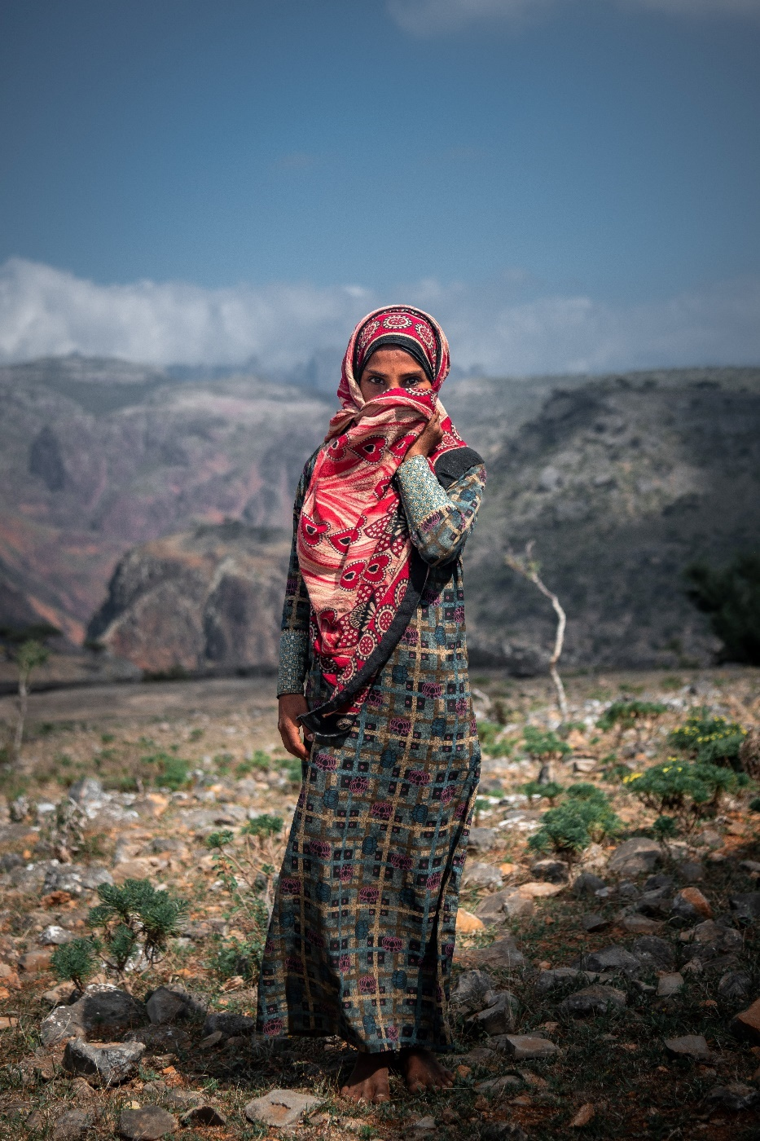
Yemeni Refugee Diaspora
Over the years, the Yemeni diaspora has settled in Saudi Arabia, the UK, the USA, Egypt, Djibouti, Somalia, UAE, and other Gulf countries. More Yemenis have found refuge in places like Egypt, Djibouti, and Somalia, with a larger influx of those leaving in recent years.
Away from the influence of their homeland, it is easier for the Yemeni diaspora to become followers of Christ, and there is a growing number of seekers.
However, there are very few intentional workers among them. Though less than 1% are believers, there are several informal house church groups. Some have also joined local churches in the countries where they are scattered.

Pray with us:
Father, you are the Shepherd of the Yemenis. As many have fled Yemen and settled in other nations, may they know the tender voice of the Shepherd who leads them beside green pastures and still waters. Where the enemy wants to steal, kill, and destroy, we bless them with the protection of their Shepherd God, who gives them abundant life. We bless Yemenis with knowing the voice of their Shepherd God, who leads them on the right paths.
Thank you for calling Yemeni believers to Yourself. We bless them as they grow in the knowledge of the Lord. May they also grow in perseverance as they follow you, Jesus. We bless them with the joy of the Lord as their strength. Father, would you enable them by your Spirit to bear witness for Jesus Christ. Amen.

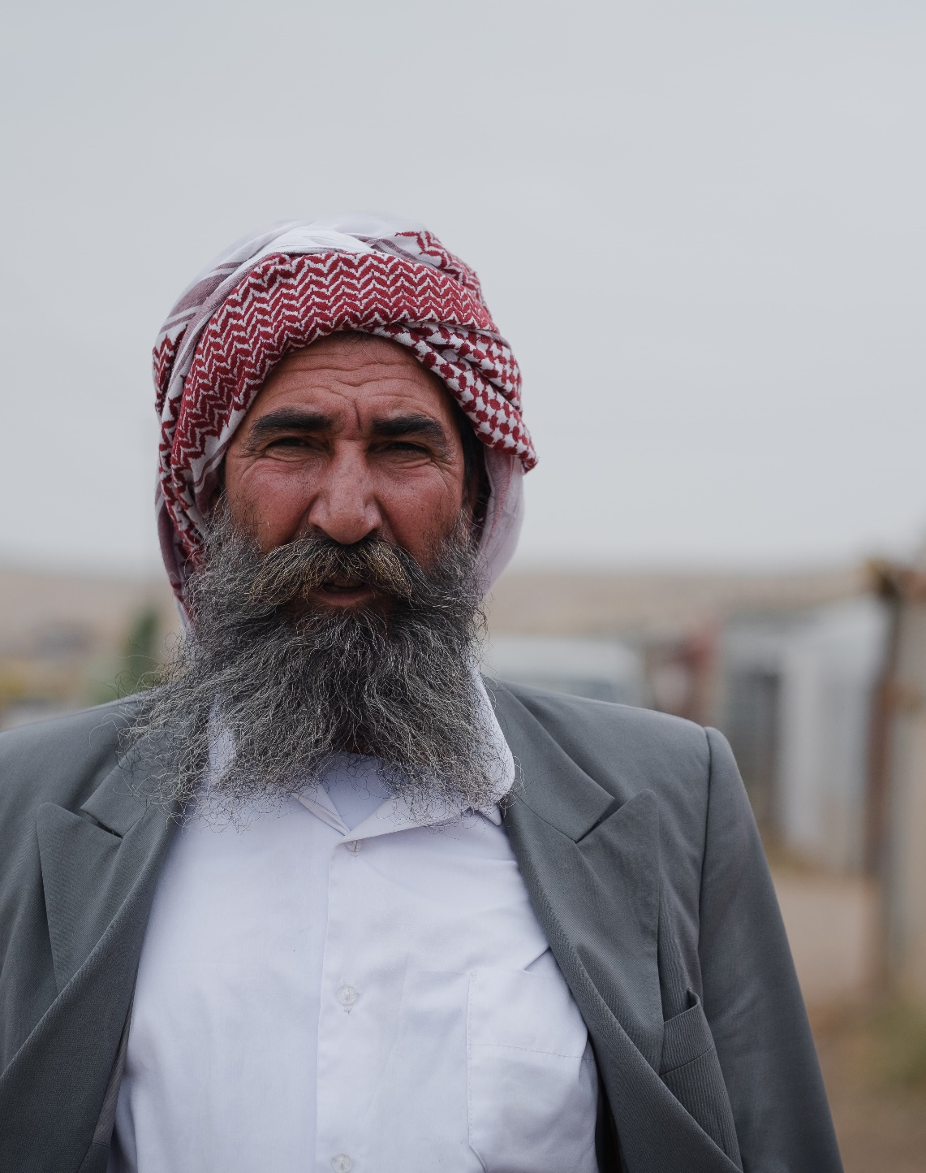
Yazidi
Although most of the 700,000 Yazidis live in the Middle East, Canada hosts a small population of about 1,500. The Yazidi practice Yazidism, a monotheistic ethnic religion that includes elements common to other faiths, like baptism, fasting, a holy pilgrimage site, and a spring holiday where they decorate eggs. Less than 0.25% of the Yazidi people would consider themselves Christian; however, there is some openness to the Gospel among younger people.
There is a three-level caste system in the Yazidi society, with many dialects across the locations and the castes. Marriages are usually arranged by their parents and kept within the same caste. However, a couple can secretly elope to get around this. Yazidis are incredibly hospitable. They have a unique style of music and dancing, and they love to dance!

Pray with us:
Living God, we were made for your courts. Father, we bless the Yazidi people with souls that long for your presence, with hearts and flesh that cry out for you, the only true God. We pray that their souls would long after you like the deer pants for water. Would your Spirit awaken their hearts to their need for you? We pray that the Yazidi people would discover that you are the only One who can fully satisfy their hunger and give them the fullness of life. Please grant them a deep desire to know you more. We bless them with the discovery that you are close to them and accessible. Amen.

v

cmacan.org

